TDS PRODUCT IMAGE SHEET – CATEGORY >
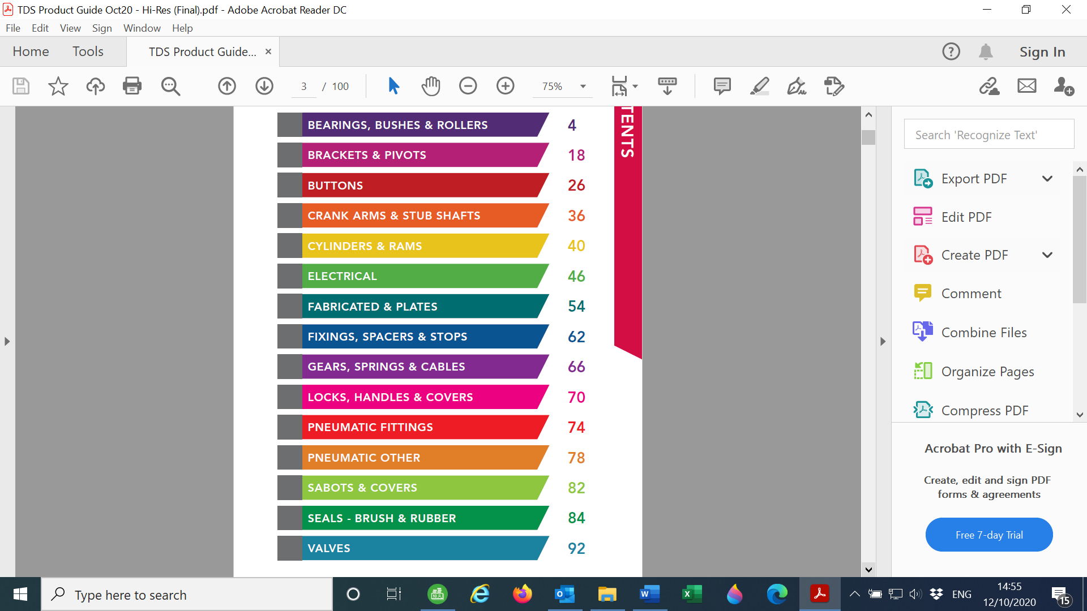
Images | TDS Part Numbers  &  Description | OE References  &  (WHERE FITTED)
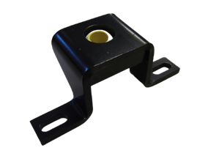 | ASY025  IG PIVOT BRACKET ASSY  # Ø14 BEARING=BRG037 | H105023 Deans
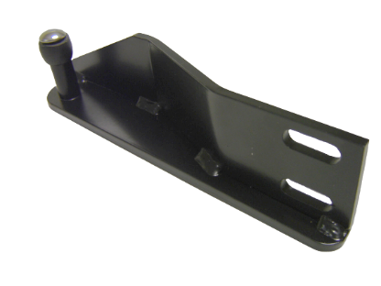 | ASY026  RH BOTTOM BEARING ASSEMBLY DEANS | H102724 Deans
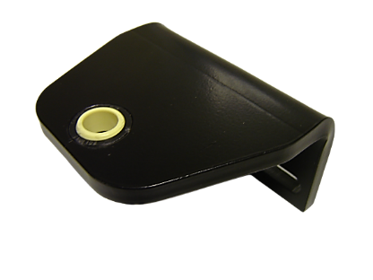 | ASY027  PIVOT BRACKET ASSY KIT DEANS  ( Ø12 BEARING=BRG046) | H105021 Deans
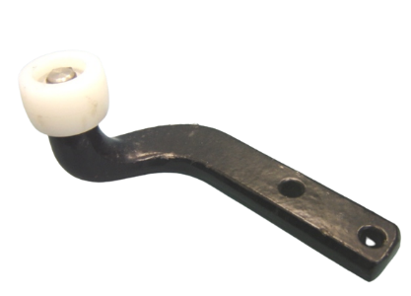 | ASY058  DEANS RH GUIDE ASSY (RLR005) | D17984 Deans
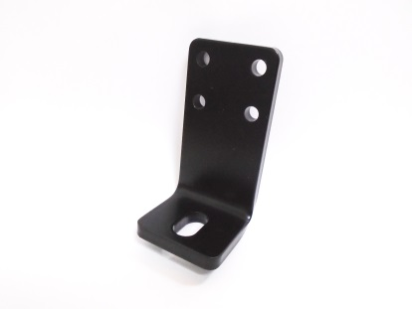 | BRK001A  BOTTOM STEADY BRACKET  WITH 10.5x21 SLOT | BRK001A TDS  (TREKABUS 16)
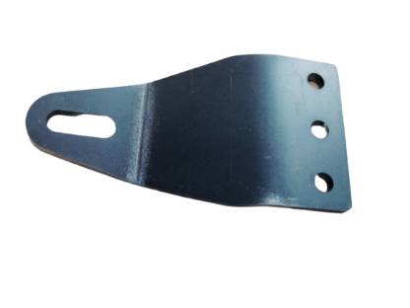 | BRK002-01 (BLACK)  BRK002-04 (WHITE)  IG DOOR GUIDE BRACKET | BRK002A TDS  (MELLOR MAXIMA)  (TREKABUS 16)
 | BRK005A  DOOR GUIDE BRACKET  FLAT OFFSET FLD | BRK005A TDS  (PARRY PPM60)
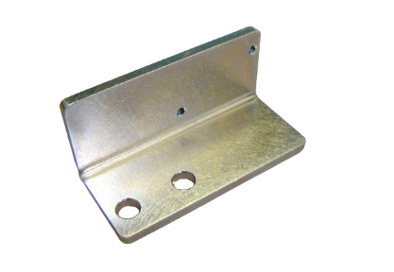 | BRK007A  MICROSWITCH MOUNT BRACKET  (SDU CLUTCH ASSY) | BRK007A TDS  (TREKABUS 16)
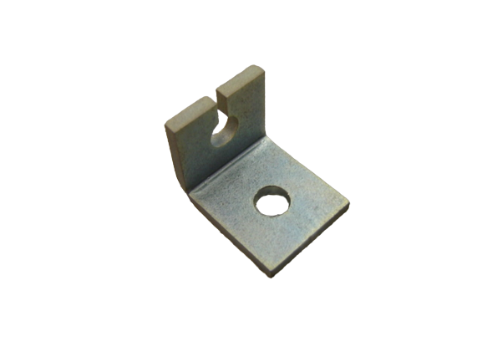 | BRK008  CABLE END BRACKET | BRK008 TDS  (TREKABUS 16)
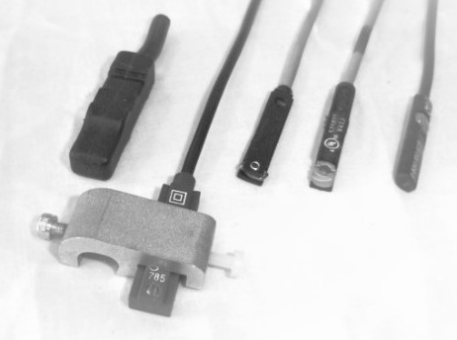 | BRK009-KIT  UNIVERSAL SENSOR MOUNT BRACKET FOR ANY  8mm < TIE ROD CYLINDERS  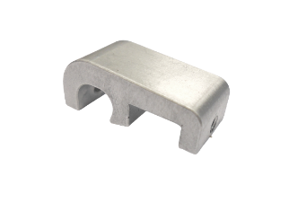 | BRK009-KIT TDS
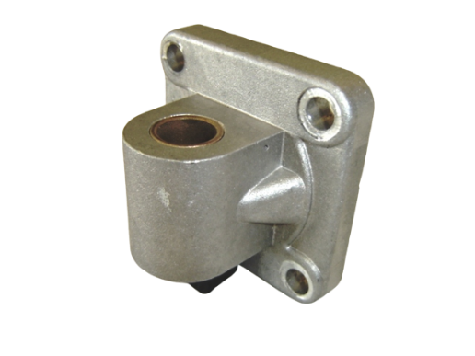 | BRK011  REAR END BRKT MALE Ø16mm  63 BORE CYLINDER | BRK011 TDS
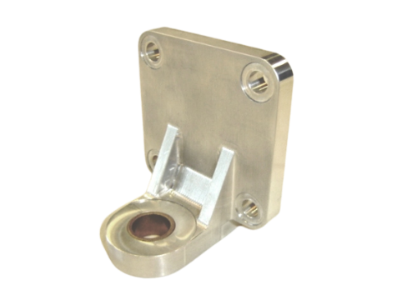 | BRK012  REAR END BRKT L SHAPE Ø16mm 63 BORE CYLINDER | BRK012 TDS
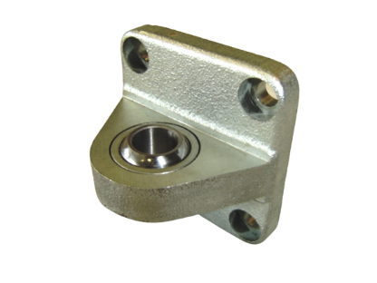 | BRK013  REAR END TRUNION SPH Ø16mm  63 BORE CYLINDER | BRK013 TDS
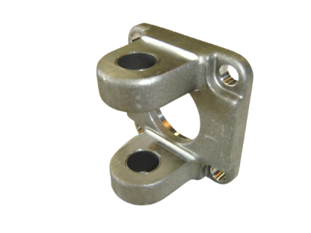 | BRK014  REAR END FEMALE TRUNION Ø16mm  63 BORE CYLINDER | BRK014 TDS
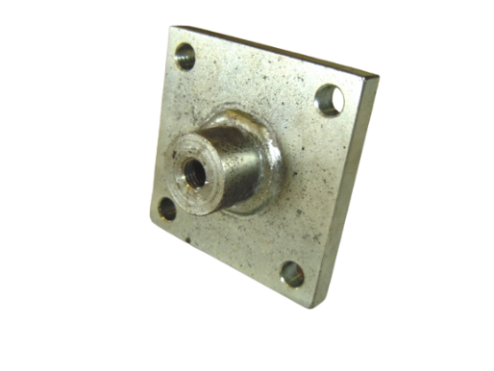 | BRK015  REAR END SPIGOT-M10  63 BORE CYLINDER | BRK015 TDS
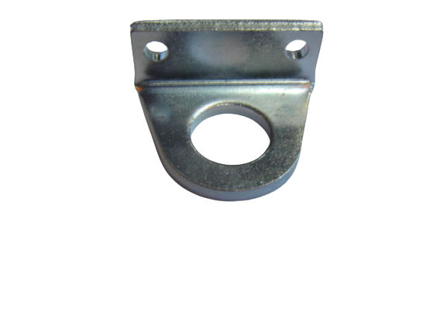 | BRK019  FOOT MOUNT  20 BORE MINI CYLINDER | BRK019 TDS
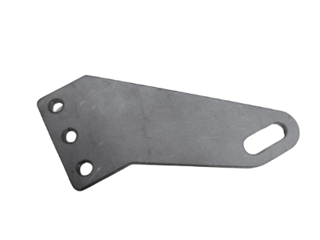 | BRK020A  FLD DOOR GUIDE BRACKET  FLAT OFFSET | BRK020A TDS  (FLD001 PARRY PPM)
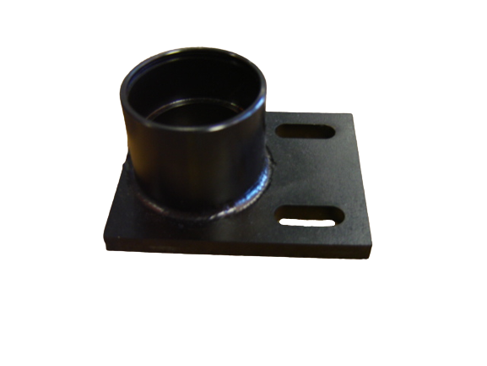 | BRK021  DOORSHAFT BEARING  HOUSING LONG  # Ø14 BEARING=BRG021B | 216760 Peters  DEP-00150
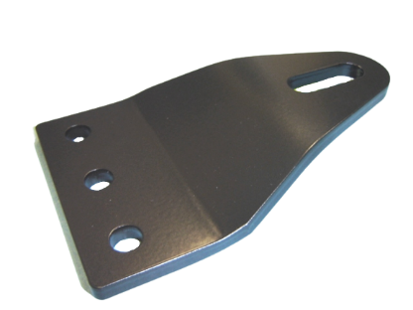 | BRK023  DOOR GUIDE USED ON TDS FLD004-5 | BRK023 TDS  (DENNIS EAGLE DUSTCART)  DEP103275
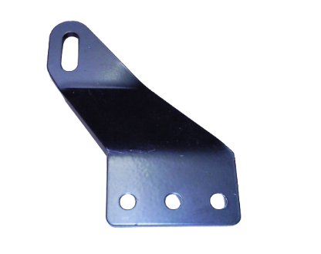 | BRK024  CRANK @ 25  RH HG=25 SLOT CTR=85x55 | BRK024 TDS
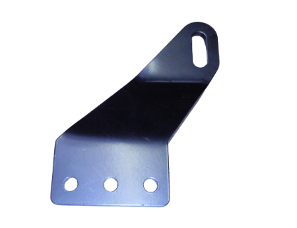 | BRK025  CRANK @ 25  LH HG=25 SLOT CTR=85x55 | BRK025 TDS
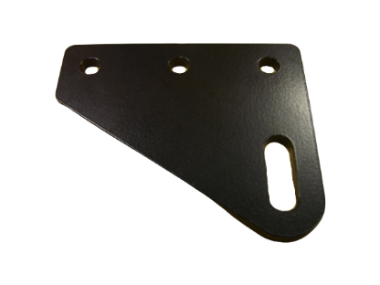 | BRK026  DOOR GUIDE BRACKET  PDS 3 HOLE | 200449 Peters
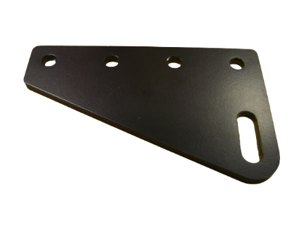 | BRK027  DOOR GUIDE BRACKET  PDS 4 HOLE | 200353 Peters
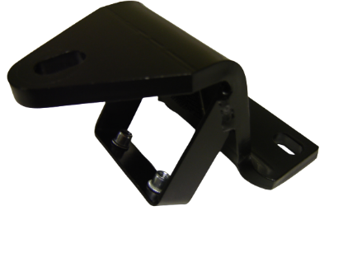 | BRK029  GUIDE BRACKET KIT DEANS | H104566 Deans
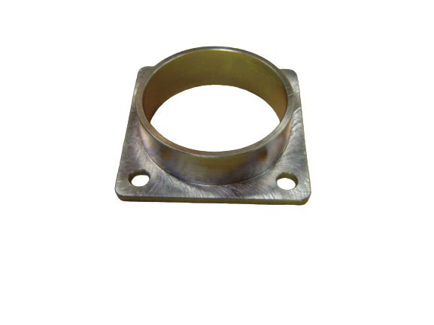 | BRK031  BEARING HOUSING  # BEARING = BRG001A | 205590 Peters
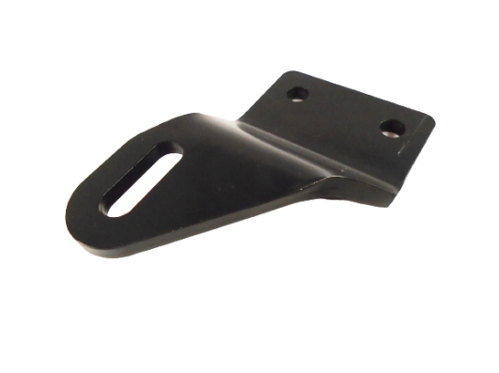 | BRK039  RH DOOR GUIDE BRACKET  CRK=22. OFFSET=66. SLOT=10x30. | 215808 Peters
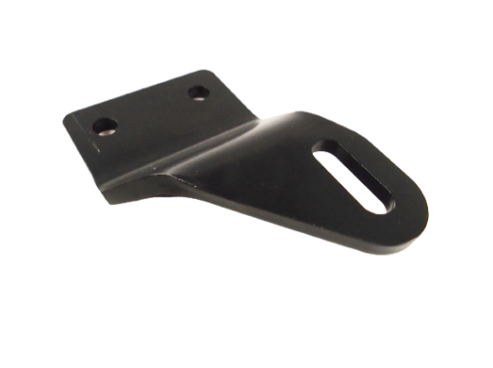 | BRK040  LH DOOR GUIDE BRACKET  CRK=22. OFFSET=66. SLOT=10x30 | 215807 Peters
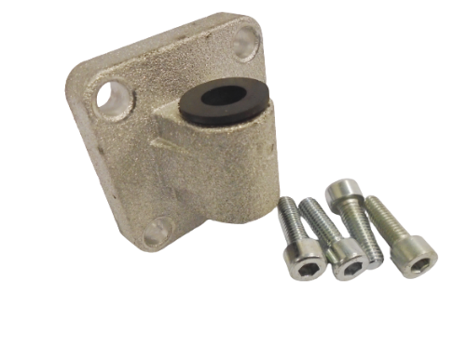 | BRK046-ASY  IG Ø12 RUBBER BUSH BRKT ASSY FOR Ø50 CYLINDERS + M8 Fixings | BRK046-ASY TDS  6600807N33
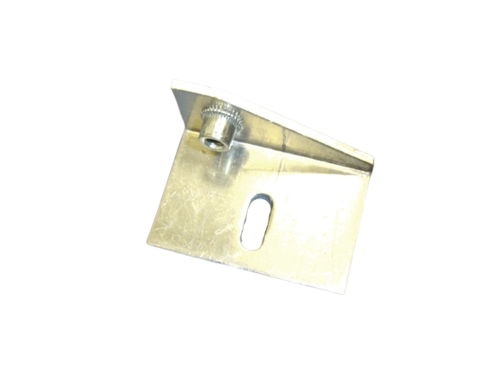 | BRK049  LH SUPPORT BRACKET | 027946 Deans  66902955
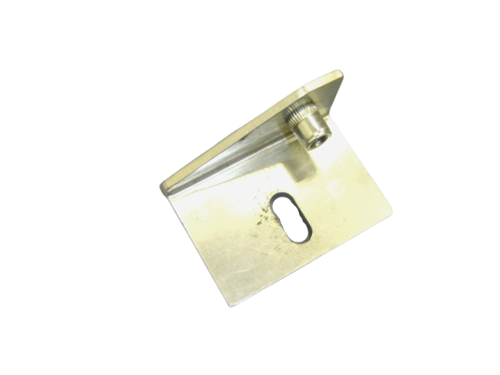 | BRK050  RH SUPPORT BRACKET | 027947 Deans  66902721
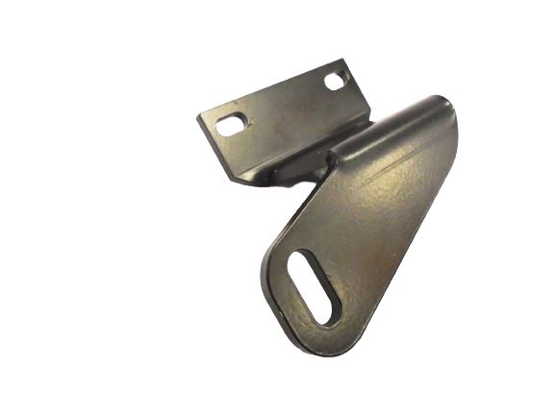 | BRK054  NO.1 DOOR GUIDE BRACKET (KKT DOOR) height=62mm | H102945 Deans
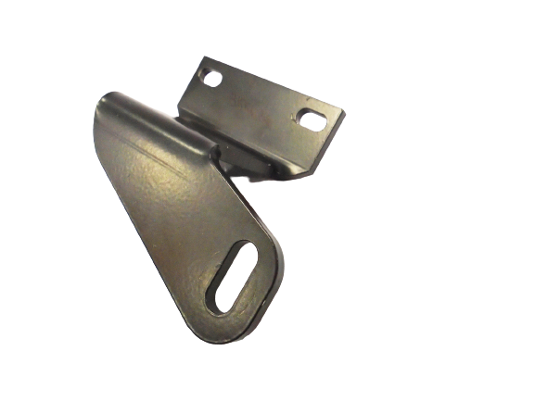 | BRK055  NO.2 DOOR GUIDE BRACKET (KKT DOOR) height=62 | H102946 Deans
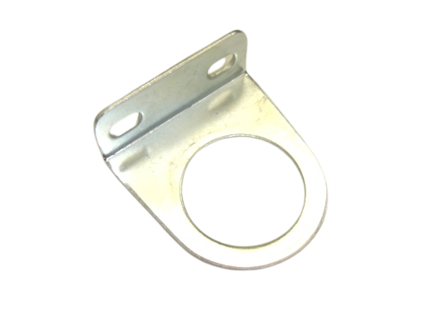 | BRK056  MOUNT BRACKET - PNE303 TDS FILTER REG RANGE  (HOLE DIA=30mm) | BRK056 TDS
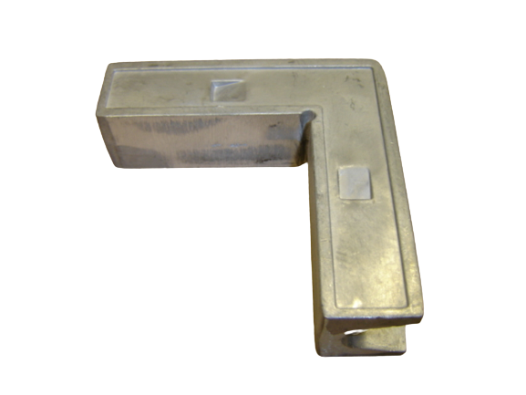 | BRK067 CORNER INSERT DEANS KEIKERT BONDED GLAZING DOORS | C49800 Deans
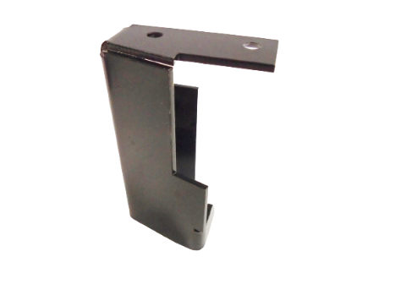 | BRK068  RH NO.1 BOTTOM LEADING EDGE BRACKET  (KEIKERT BONDED GLASS DOORS) | H107216 Deans
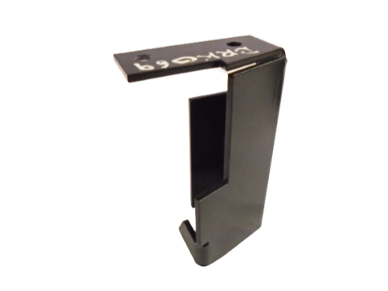 | BRK069  LH NO.2 BOTTOM LEADING EDGE BRACKET  (KEIKERT BONDED GLASS DOORS) | H107217 Deans  6690811N05
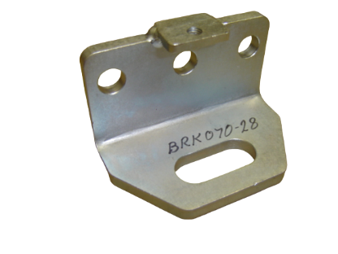 | BRG070-28  M12 SLOTxM8 FIXINGS  BY 28mm DEEP CTRS | BRG070-28 TDS  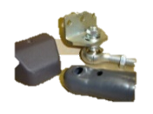  FOR PLUG DOOR PIVOT ARMS, ALSO SEE >  BRG073  RUB045  SAB040
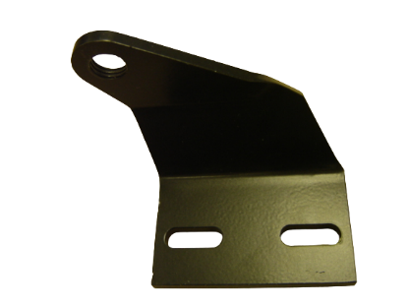 | BRK071  No1 LH DOORGUIDE BRACKET | 027724 Deans
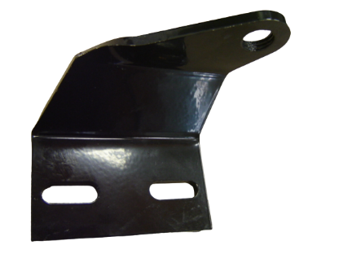 | BRK072  No2 RH DOORGUIDE BRACKET | 027725 Deans
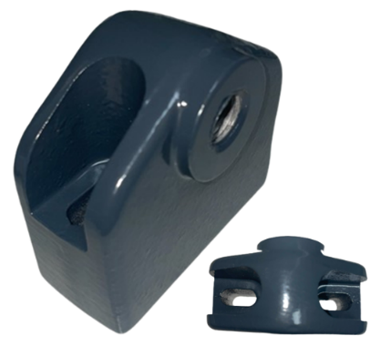 | BRK079  MASATS TOP CONTROLLER | 475215C0A Masats
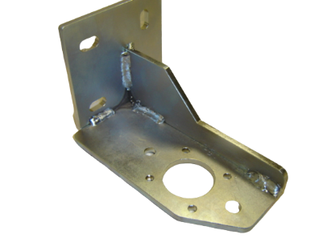 | BRK080-01RH  BEARING SUPPORT BRACKET  RH CENTRE | BRK050-01RH TDS
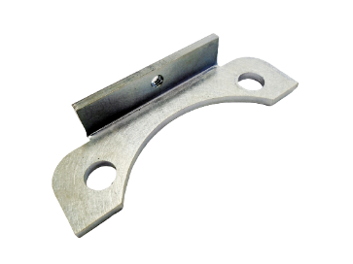 | BRK083  ROTARY LOCK & COVER RETAINING BRACKET | BRK083 TDS  USED WITH HDL039T GLASS MOUNT ROTARY LOCK SYSTEM
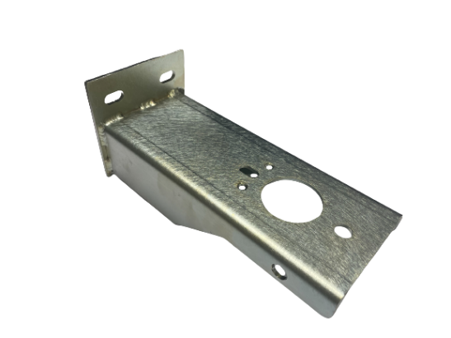 | BRK084  UNVERSAL BRACKET OFF SET @ 160 CTR  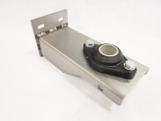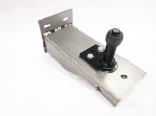 | BRK084 TDS
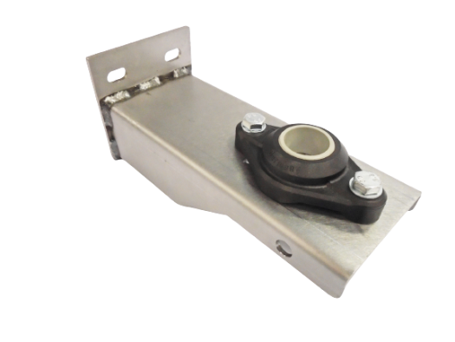 | BRK084-01-ASSY UPPER DOORSHAFT BRG  (25dia X 160 OFF SET) ASSY  # BEARING = BRG022B | BRK084-01-ASSY TDS
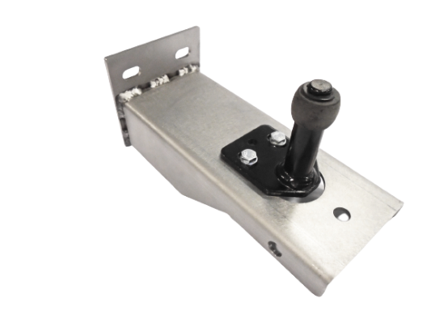 | BRK084-02-ASSY LOWER DOORSHAFT BRG  (25dia x 160 OFF SET) ASSY  # BOTT BEARING = ASY006B | BRK084-02-ASSY TDS
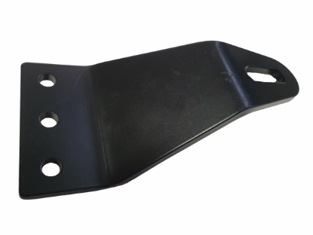 | BRK085 | BRK085 TDS
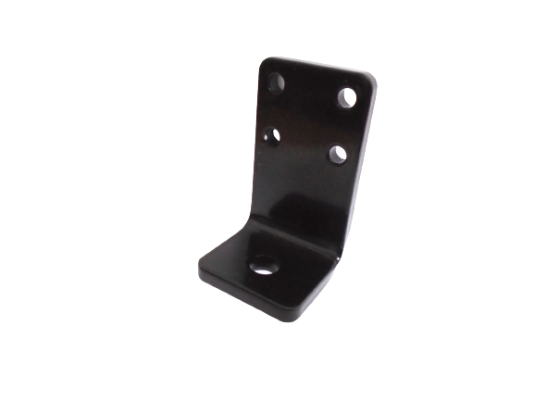 | BRK101  STABILIZER & DOOR GUIDE BRACKET with Ø10 hole | BRK101 TDS
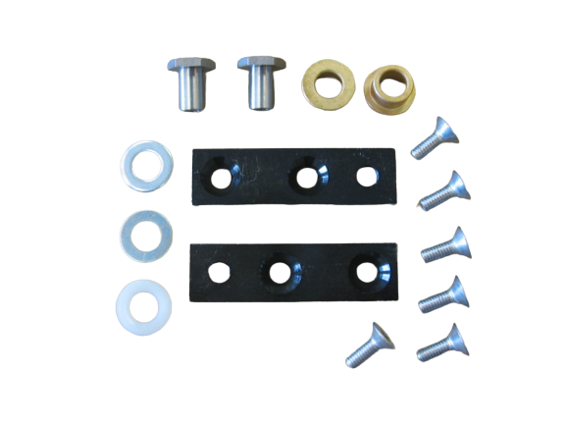 | KIT010  IG DOORSHAFT PIVOT FIXING KIT | 100-051-KIT Peters  66903056
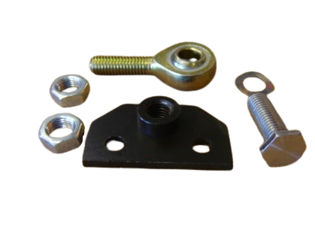 | KIT014  PIVOT KIT PDS GLIDER  TOP OR BOTTOM M12x1.75 | 100-034-KIT Peters  (100-084-KIT)
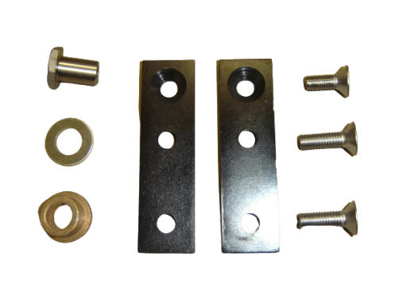 | KIT023  PDS DOORSHAFT FIXING KIT | 100-57-A4 Peters
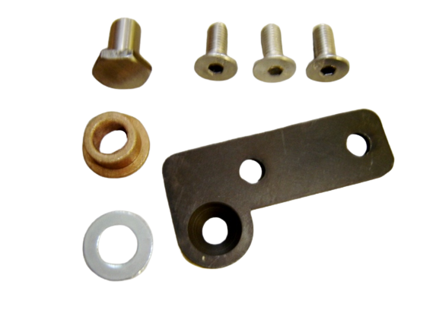 | KIT027  M12 SPH TOP/OILT BOTT FIT  FOR RH DOOR VIEWED FROM INSIDE VEHICLE | 100-040RL-KIT Peters  (OPTARE EXCEL)
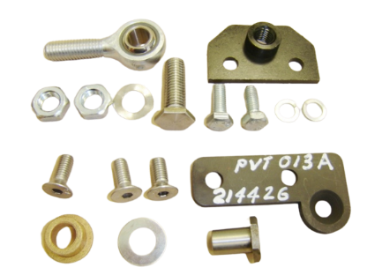 | KIT028  M12 SPH TOP/OILT BOTT FIT  FOR LH DOOR VIEWED FROM INSIDE VEHICLE | 100-040LL-KIT Peters  (OPTARE EXCEL)
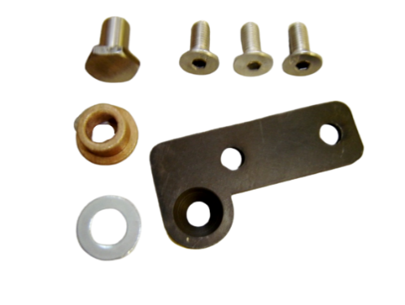 | KIT027-BRL  OILTE BOTTOM PIVOT KIT  FOR LH DOOR VIEWED FROM INSIDE VEHICLE | 100-040-A4 Peters  (OPTARE EXCEL)
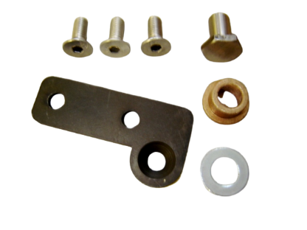 | KIT028-BLL  OILTE BOTTOM PIVOT KIT  FOR LH DOOR VIEWED FROM INSIDE VEHICLE | 100-040-A4 Peters  (OPTARE EXCEL)
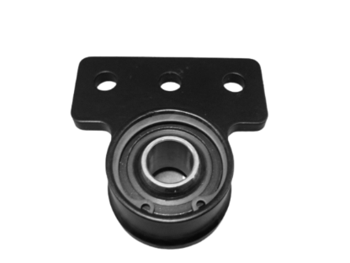 | L500-05-ASSY-01  IG UPPER BEARING BRACKET ASSY  # SPH BEARING = BRG021B  # RETAINER CIRCLIP = CIR001A  # PROTECTIVE CAP = CAP001A | L500-05-ASSY-01 TDS  (ALL OPTARE VEHICLES – TDS DOOR)  DP0383826
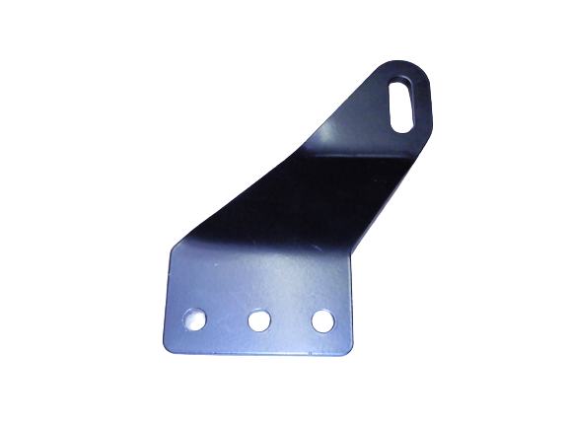 | L500-06-LH  IG DOOR GUIDE BRACKET LH  # GUIDE SPINDLE = ASY004B | L500-06-LH TDS  (ALL OPTARE VEHICLES – TDS DOOR  EXCEPT OLYMPUS DD)  32450027
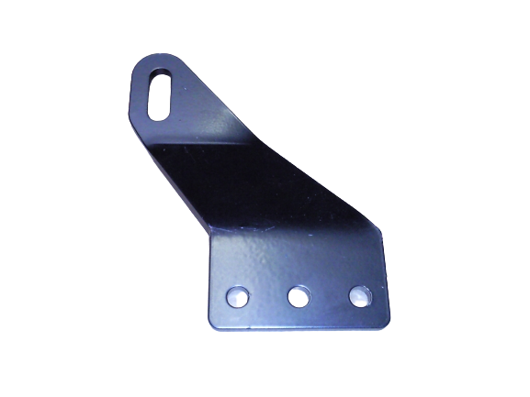 | L500-06-RH  IG DOOR GUIDE BRACKET RH  # GUIDE SPINDLE = ASY004B | L500-06-RH TDS  (ALL OPTARE VEHICLES – TDS DOOR  EXCEPT OLYMPUS DD)  32450028
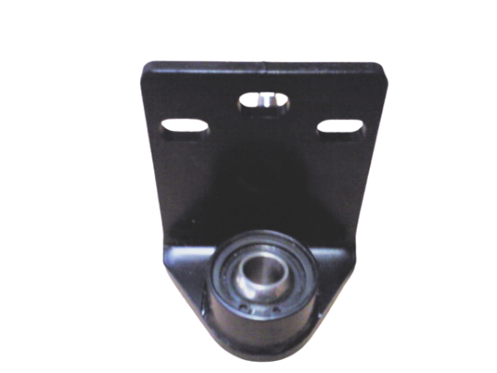 | L500-09-ASSY-01  IG LOWER BEARING BRACKET ASSY  # SPH BEARING = BRG021B  # RETAINER CIRCLIP = CIR001A  # PROTECTIVE CAP = CAP001A | L500-09-ASSY-01 TDS  (ALL OPTARE VEHICLES – TDS DOOR)  6690832N00
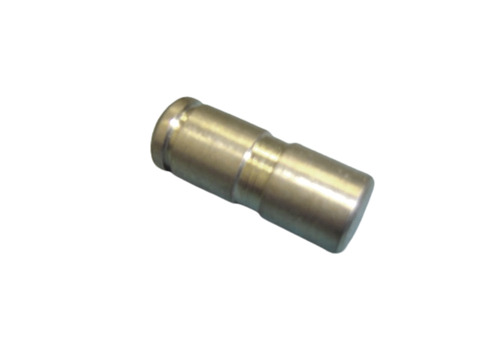 | PVP003  Ø12 CLEVIS CLUTCH PIN | 214677 Peters
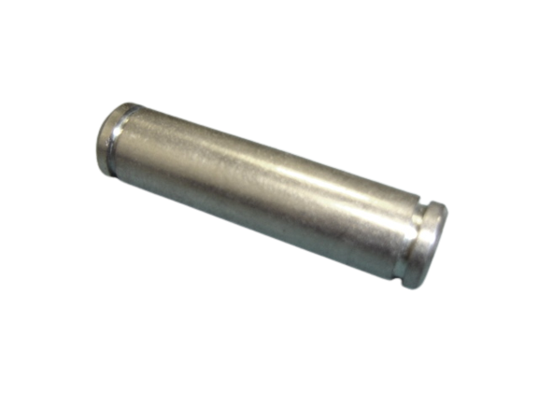 | PVP005  Ø12 x 40 PIVOT PIN | 213548 Peters
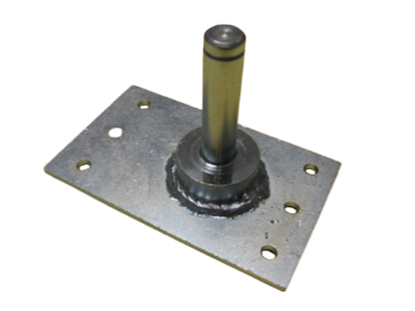 | PVT001A  Ø12 REAR PIVOT PLATE  ELEC ACTUATOR | 214664 Peters
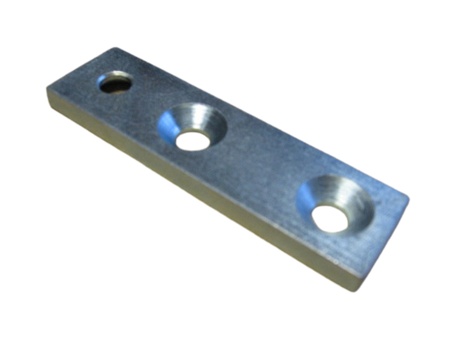 | PVT002A  DOOR PIVOT PLATE | 201361 Peters  201361  204730
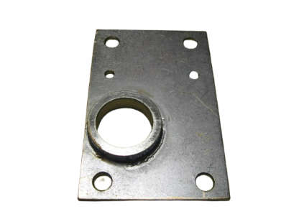 | PVT003A  RH BEARING PIVOT PLATE | 214750 Peters
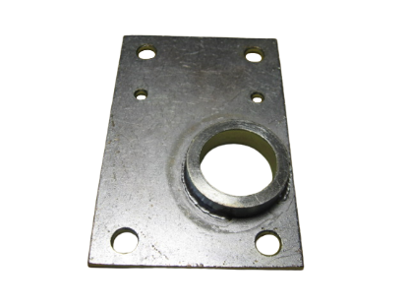 | PVT004A  LH BEARING PIVOT PLATE | 214751 Peters
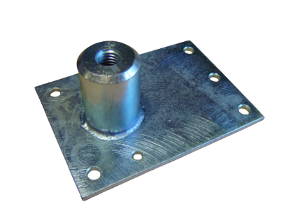 | PVT005A  M12 ACTUATOR PIVOT PLATE | 217117 Peters
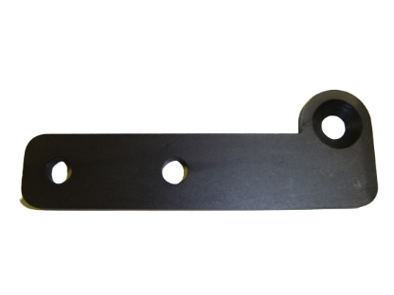 | PVT008A  PIVOT PLATE RH | 201348 Peters
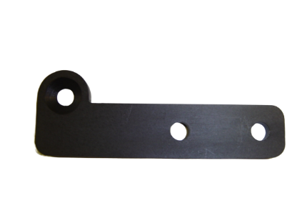 | PVT009A  PIVOT PLATE LH | 201349 Peters
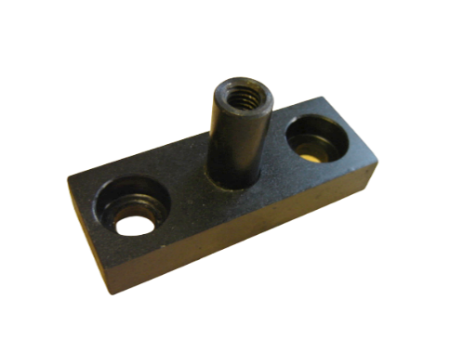 | PVT010A  IG DOOR HINGE BLOCK  LONG- Ø12.7 Spigot  # RODEND = BRG012B-ASSY,  BOLT = SCR20816-A2, WASHER = WAS08PL-C1, SPACER = SPA012, BOOT = RUB201 | E25408 Deans  16R0121  16R0131
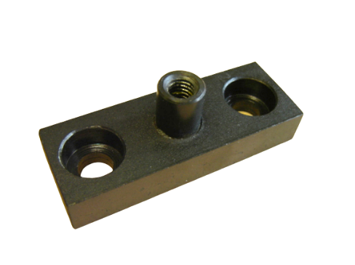 | PVT011A  IG DOOR HINGE BLOCK  SHORT- Ø12.7 Spigot  # RODEND = BRG012B-ASSY,  BOLT = SCR20816-A2, WASHER = WAS08PL-C1 | E25407 Deans  16R0120
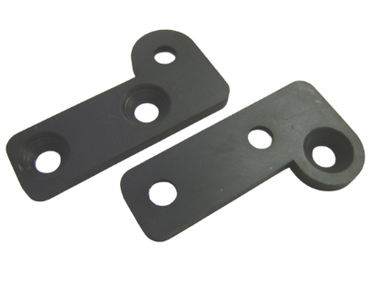 | PVT013A  SHORT PIVOT PLATE  TOP RH | 214426 Peters
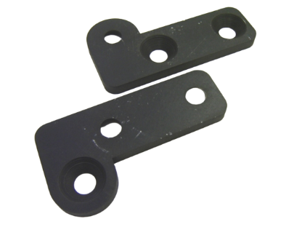 | PVT014A  SHORT PIVOT PLATE  TOP LH | 214427 Peters
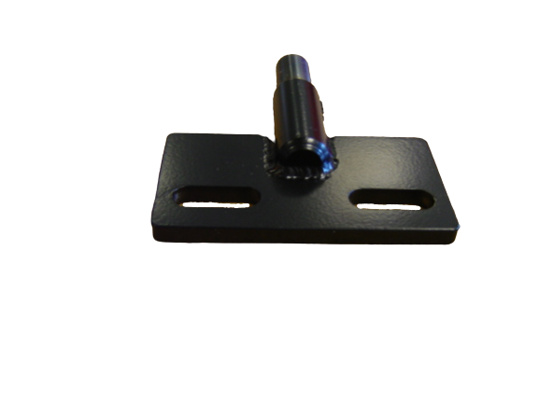 | PVT015A  LOWER HINGE  PIVOT BRACKET- Ø12.7 Spigot | D31431 Deans
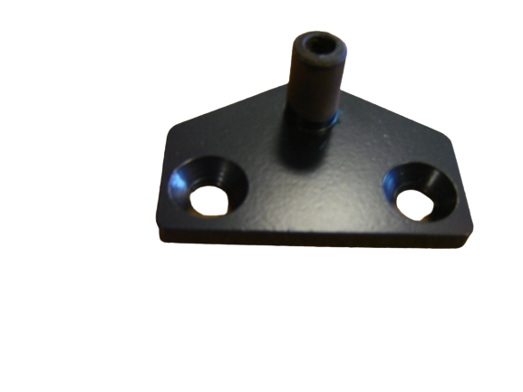 | PVT016A  UPPER HINGE  PIVOT BRACKET- Ø12.7 Spigot | D31388 Deans
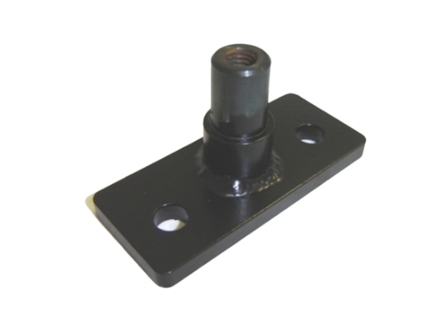 | PVT017A  UPPER BEARING  PIVOT BRACKET Ø14 Spigot | PVT017A TDS
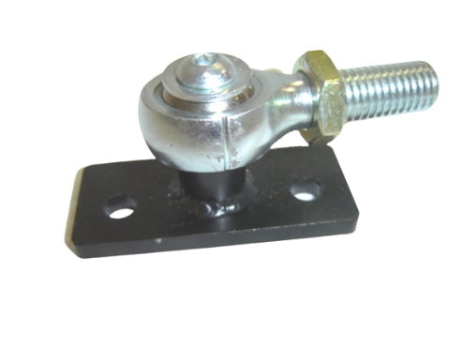 | PVT017-ASY  IG M14 UPPER BEARING  PIVOT ASSY  # RODEND = BRG015B  # PIVOT PLATE = PVT017 | PVT017-ASY TDS  29455017  660835N00
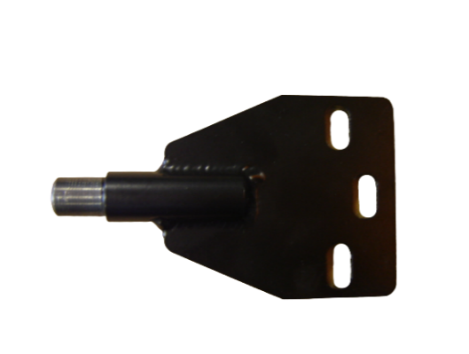 | PVT018A  Ø14 LOWER BEARING  PIVOT BRACKET- Ø14 Spigot | PVT018A TDS
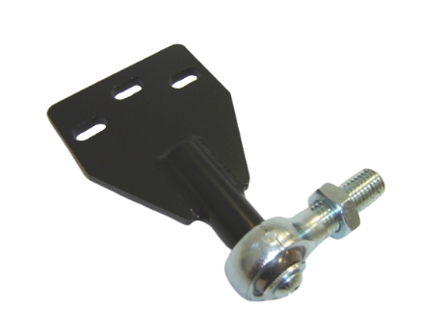 | PVT018-ASY  IG M14 LOWER BEARING  PIVOT ASSY  # RODEND = BRG015B  # PIVOT PLATE = PVT018  # PROTECT BOOT = RUB201 | PVT018-ASY TDS  6690836N00  294550018  16R0236
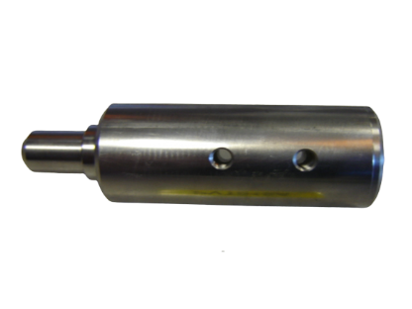 | PVT019A  O/D=31.65 x 82(O/L=110)  Ø14BOTTOM SPIGOT  FITS INTO O/D 38mm DOORSHAFT | 216755 Peters  33-19078-2
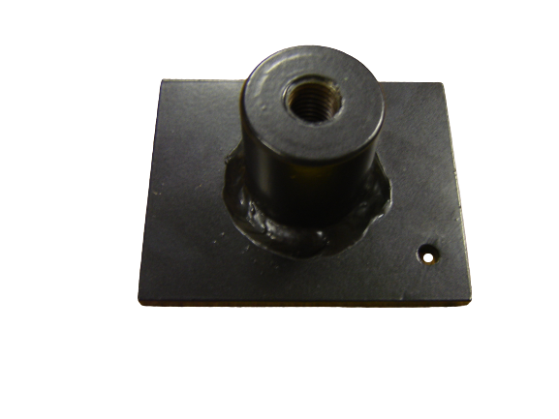 | PVT022  M12 REAR PIVOT PLATE RETROFIT ON TO SHELFPLATE  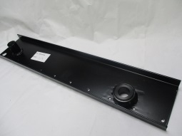 | RETROFIT PART FOR  FITTING TO PETERS UPPER SHELFPLATE 217721  BASE SHELFPLATE =  HPA034 TDS  (EAST LANCS OMNIDECK)
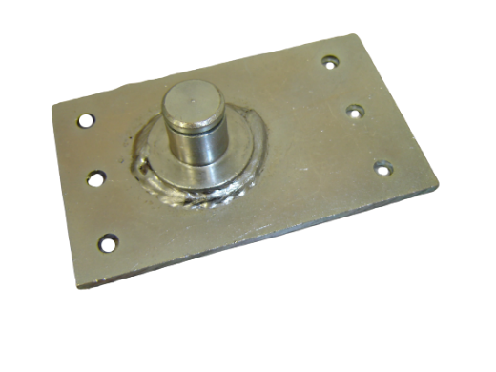 | PVT023A  Ø16 REAR PIVOT PLATE  FOR PNEU ACTUATOR | 200348 Peters
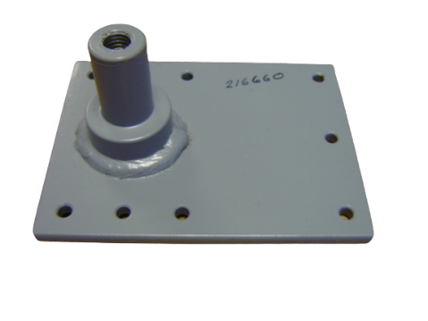 | PVT025  Ø3/4 PIVOT BRACKET  WELD ASSY | 214660 Peters
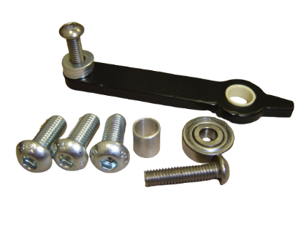 | PVT029  PS LOWER PIVOT ARM ASSY  (DEANS PS) | 088099 Deans
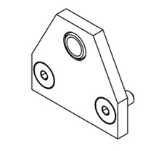 | PVT031  LOWER PIVOT HINGE PLATE WITH BRG | PVT031 TDS
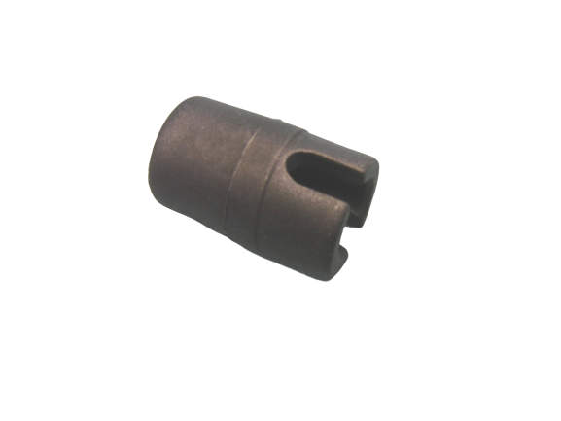 | ROD101  DRIVE ROD END COULPING | ROD101 TDS
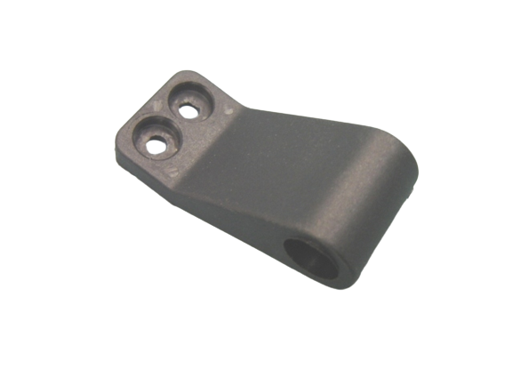 | ROD102  DRIVE ROD SUPPORT BRACKET | ROD102 TDS
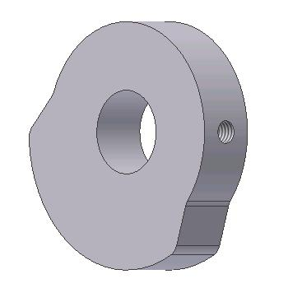 | B470  PS SWITCH CAM SHAFT | B470 Ventura  DEP-00218  DSP-00090  42-5145-178
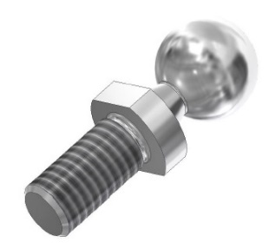 | B585  IG4 PIVOT BOLT M6 | B585 Ventura  WRIGHTBUS STREETLITE IGE
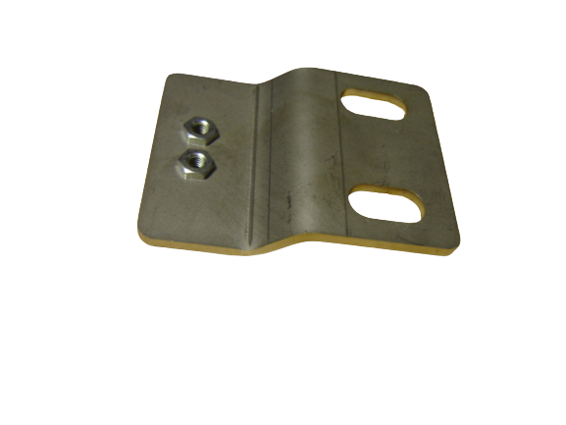 | C592  PS CATERPILLAR CABLE  SUPPOR BRACKET | C592 Ventura
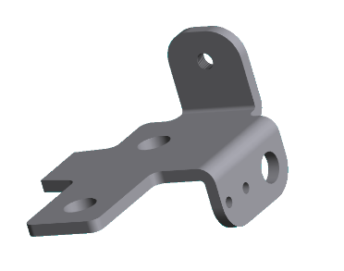 | B680  PS END PLATE RIGHT | B680 Ventura  DED-00270
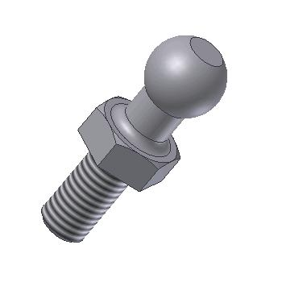 | B688  PS PIVOT BOLT 16xM10 (PS) | B688 Ventura  (PS BOTTOM SUPPORT ASSY)  DED-00270  6690818D31  42-5145-688
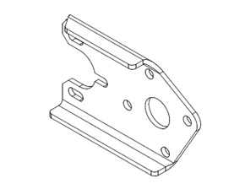 | C727  RS ACTUATOR BRACKET LH | C727 Ventura
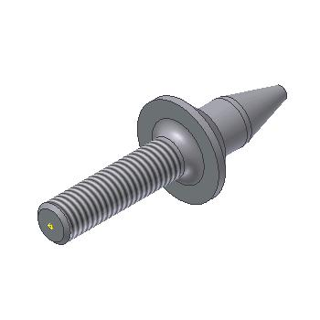 | C924  PS CATCH PIN | C924 Ventura  DED-00393
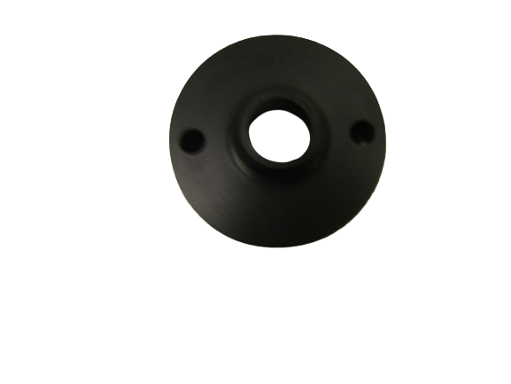 | C965  PS CATCH BLOCK (EARLY) | C965 Ventura
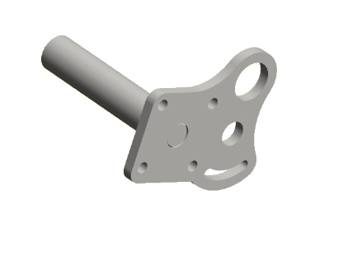 | D088  PS FRONT CYLINDER BRACKET  (FOR D622/E820/I486) | D088 Ventura  42-5145-139
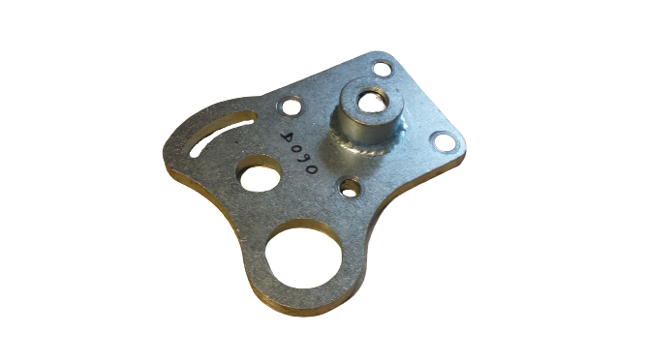 | D090  PS CYLINDER BRACKET  (REAR D622) | D090 Ventura  42-5145-140
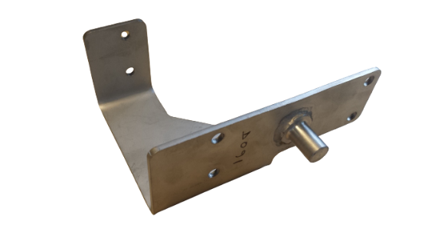 | D091  PS CYLINDER BRACKET  (CARRIAGE D622) | D091 Ventura  42-5145-143
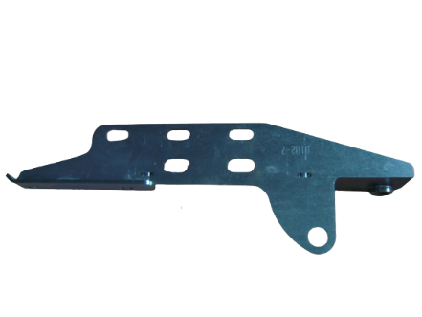 | D102  PS CAM ROLLER BRACKET | D102 Ventura  42-5145-117
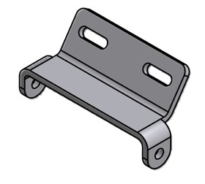 | D135  PS TENSION BRACKET | D135 Ventura  42-5145-123
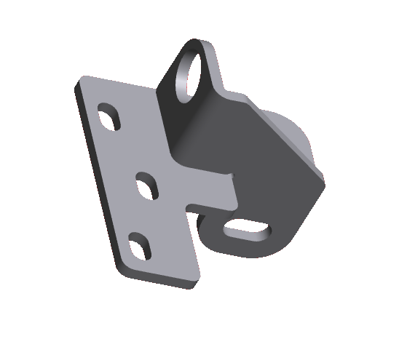 | D525  PS BOTTOM SUPPORT LH | D525 Ventura  42-5145-173
 | D526  PS BOTTOM SUPPORT RH | D526 Ventura  42-5145-174
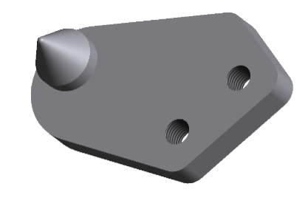 | D545  PS CATCH PIN PLATE LH | D545 Ventura  42-5145-025
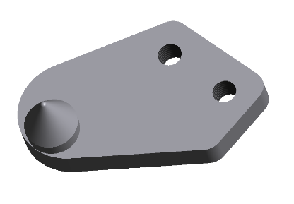 | D546  PS CATCH PIN PLATE RH | D546 Ventura  42-5145-017
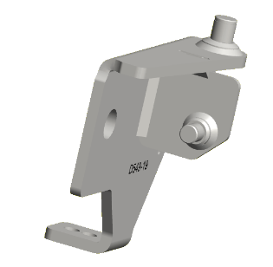 | D549  PS ENDPLATE RH WELD ASSY | D549 Ventura  42-5145-103
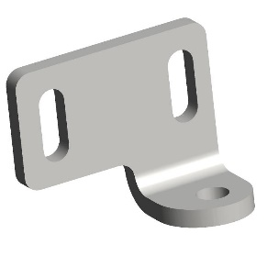 | D703  PS DOORSHAFT ADJUSTING BRACKET LH | D703 Ventura
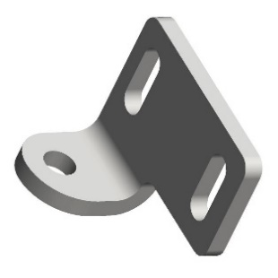 | D704  PS DOORSHAFT ADJUSTING BRACKET RH | D704 Ventura  6600800N33
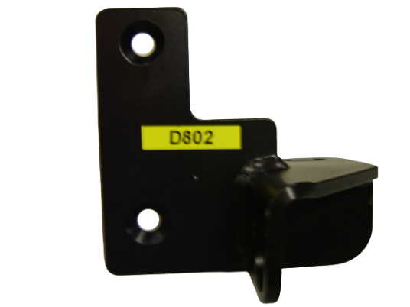 | D802  PS SUPPORT BRACKET  DOORSHAFT RH | D802 Ventura  DED-00207
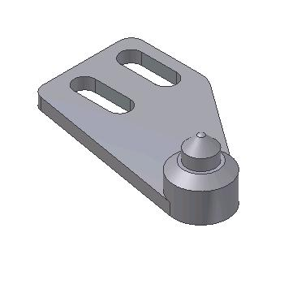 | E096  PS CATCH PIN PLATE RH | E096 Ventura  DED-00383  6690821D31
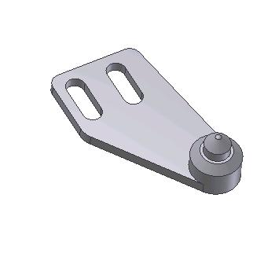 | E097  PS CATCH PIN PLATE LH | E097 Ventura  DED-00384  6690820D31
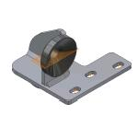 | E121  PS BOTTOM SUPPORT ASSY LH  # PIVOT BOLT = B688  # CATCH BLOCK = D803 | E121 Ventura ADL E200 SD PS + E400 DD PS, MCV SD EVOLUTION PS  6600023N33
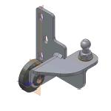 | E122  PS BOTTOM SUPPORT ASSY RH  # PIVOT BOLT = B688  # CATCH BLOCK = D803 | E122 Ventura ADL E200 SD PS + E400 DD PS, MCV SD EVOLUTION PS  6600024N24
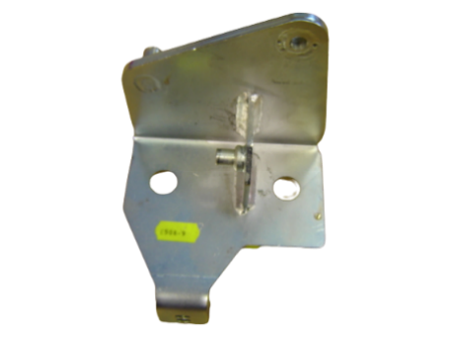 | E508  PS END PLATE LEFT WELD ASSY | E508 Ventura
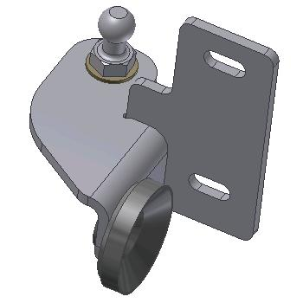 | E818  PS BOTTOM SUPPORT ASSY LH  # PIVOT BOLT = B688  # CATCH BLOCK = D803 | E818 Ventura WRIGHTBUS ECLIPSE SD IG3 + GEMINI DD IG3 + STREETCAR PS , ADL E400 DD IG3, EAST LANCS SD IG3/PS + OLYMPUS DD PS, POLISH SCANIA OMNICITY DD IG3/PS, EAST LANCS Olympus DD IG3  DED-00340  DEC-00406
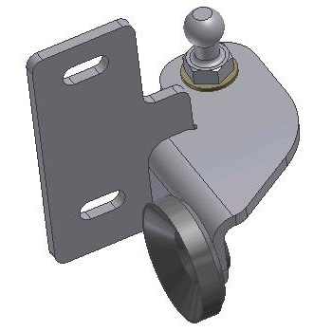 | F302  PS BOTTOM SUPPORT ASSY RH  # PIVOT BOLT = B688  # CATCH BLOCK = D803 | F302 Ventura WRIGHTBUS ECLIPSE SD IG3 + GEMINI DD IG3 + STREETCAR PS , ADL E400 DD IG3, EAST LANCS SD IG3/PS + OLYMPUS DD PS, POLISH SCANIA OMNICITY DD IG3/PS, EAST LANCS Olympus DD IG3  DED-00343  DEC-00405
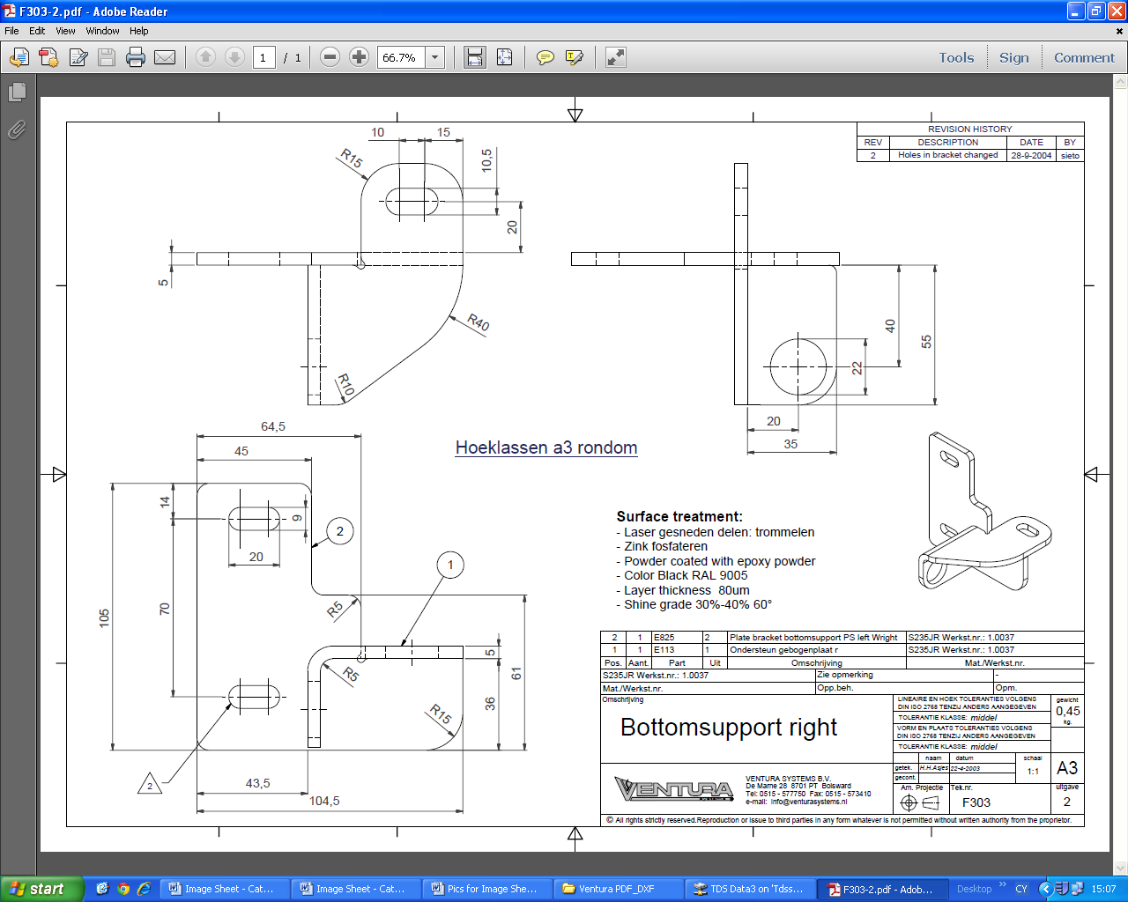 | F303  PS BOTTOM SUPPORT RIGHT | F303 Ventura WRIGHTBUS GEMINI DD PS
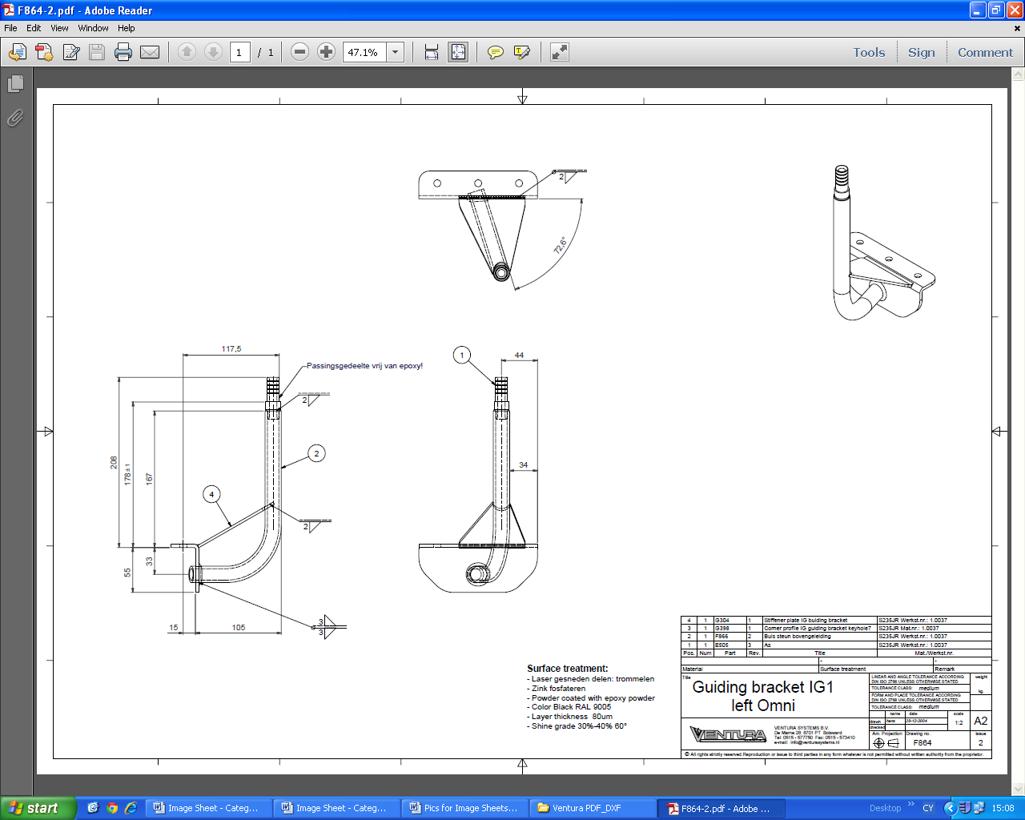 | F864  IG3 GUIDING BRACKET LH OMNI | F864 Ventura  POLISH SCANIA OMNICITY DD IG3/PS
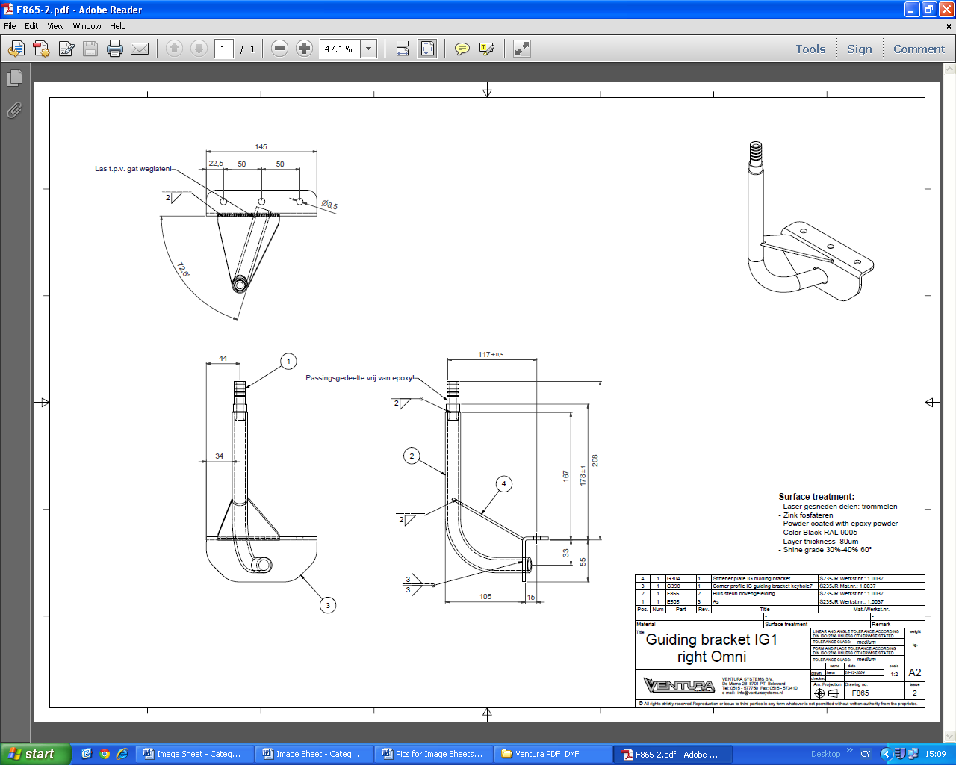 | F865  IG3 GUIDING BRACKET RH OMNI | F865 Ventura  POLISH SCANIA OMNICITY DD IG3/PS
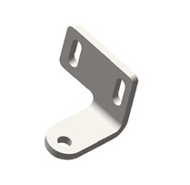 | F913  PS DOORSHAFT ADJUSTER BRACKET LH 43MM | F913 Ventura  6600801N196
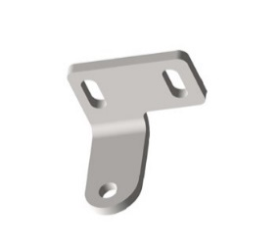 | F914  PS DOORSHAFT ADJUSTER BRACKET RH 43MM | F914 Ventura  6600800N196
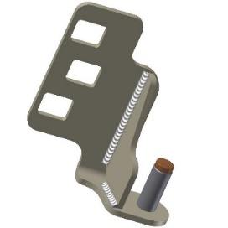 | G257  IG3 DOOR SHAFT SUPPORT  LH ASSY | G257 Ventura POLISH SCANIA OMNICITY DD IG3
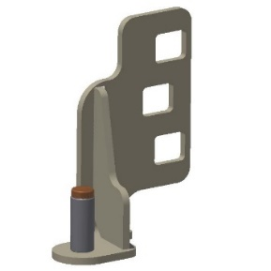 | G298  IG3 DOOR SHAFT SUPPORT  RH ASSY | G298 Ventura POLISH SCANIA OMNICITY DD IG3
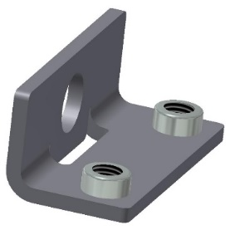 | G379  IG3 LOWER SHAFT BRACKET LH  # BUSH = H074 | G379 Ventura  DEV-00245  DP038838
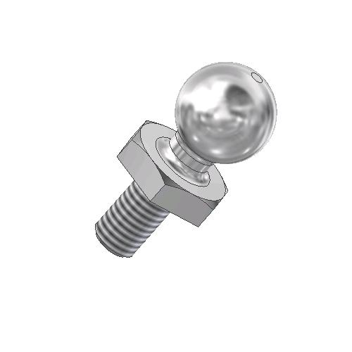 | G951  IG4 M10 PIVOT BOLT 21DIA | G951 Ventura  DEV-00027  6600806N33
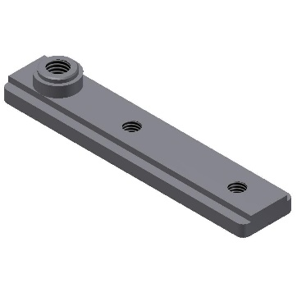 | G955  IG SUSPENSION PIVOT PLATE | G955 Ventura  DEV-00090  6690804N26
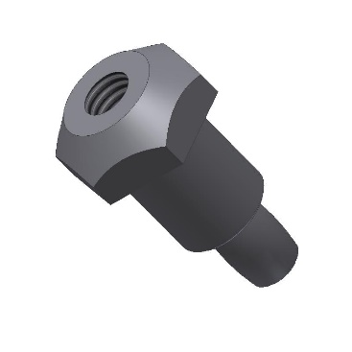 | G989  IG3 PIVOT PIN | G989 Ventura  DED-00441  6690803N41
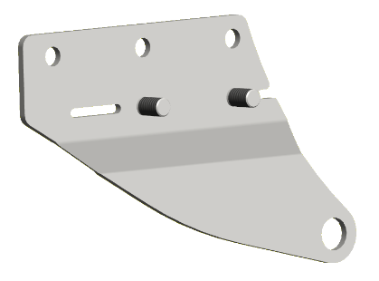 | H036  PS DRIVE BRACKET ASSY  # BEARING BUSH = D107 | H036 Ventura  DEV-00222  6690807D252
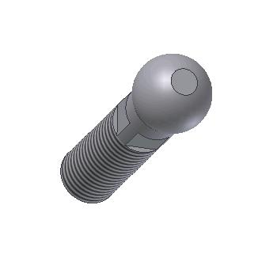 | H096  PIVOT BOLT M12 | H096 Ventura
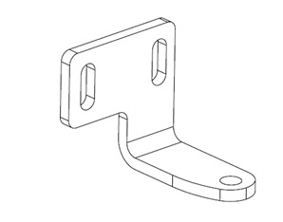 | H227  PS DOORSHAFT ADJ BRACKET RH | H227 Ventura
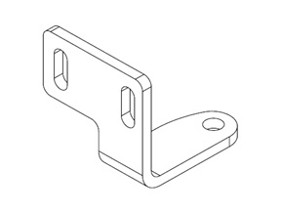 | H228  PS DOORSHAFT ADJ BRACKET LH | H228 Ventura
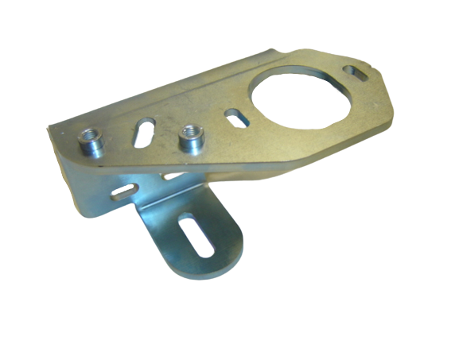 | H430  IG3 FRAME BRACKET RH | H430 Ventura
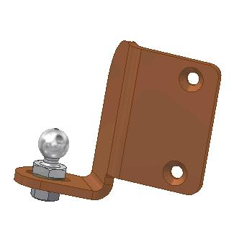 | H437  IG3 DOORSHAFT SUPPORT RH  # PIVOT BOLT = G951 | H437 Ventura WRIGHTBUS ECLIPSE SD IG3 + GEMINI DD IG3, ADL E400 DD IG3, EAST LANCS SD IG3, EAST LANCS Olympus DD IG3  DEV-00026
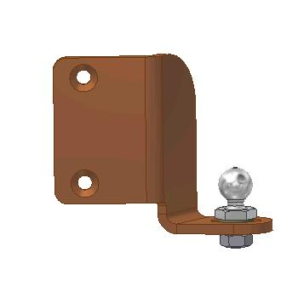 | H465  IG3 DOORSHAFT SUPPORT RH  # PIVOT BOLT = G951 | H465 Ventura WRIGHTBUS ECLIPSE SD IG3 + GEMINI DD IG3, ADL E400 DD IG3, EAST LANCS SD IG3, EAST LANCS Olympus DD IG3  DEV-00025
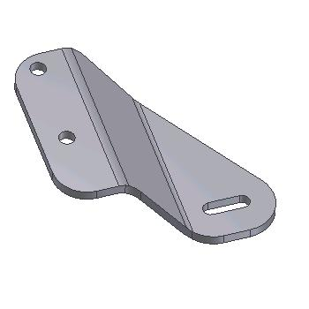 | H502  IG3 GUIDING BRACKET LH | H502 Ventura WRIGHTBUS ECLIPSE SD IG3 + GEMINI DD IG3, ADL E300 SD IG3, EAST LANCS SD IG3  DED-00420
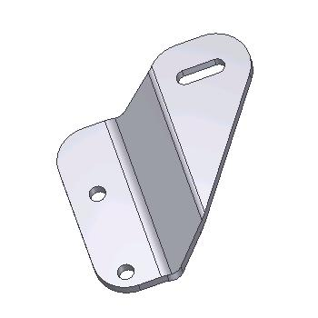 | H508  IG3 GUIDING BRACKET RH | H508 Ventura WRIGHTBUS ECLIPSE SD IG3 + GEMINI DD IG3, ADL E300 SD IG3, EAST LANCS SD IG3  DED-00421
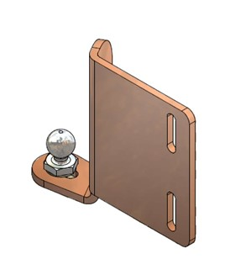 | H776  IG3 BOTTOM SUPPORT LH 135  # PIVOT BOLT = G951 | H776 Ventura  6600006N26
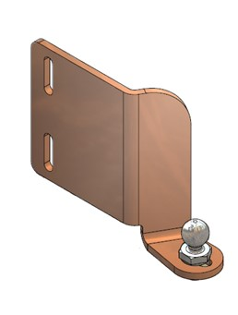 | H777  IG3 BOTTOM SUPPORT RH 135  # PIVOT BOLT = G951 | H777 Ventura  6600007N26
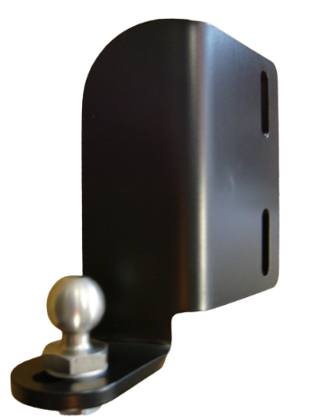 | H987  IG3 DOOR SHAFT SUPPORT  LH ASSY  # PIVOT BOLT = G951 | H987 Ventura WRIGHTBUS ECLIPSE SD IG3 + GEMINI DD IG3, ADL E400 DD IG3, EAST LANCS SD IG3 + OLYMPUS DD IG3, POLISH SCANIA OMNICITY DD IG3  33-11188
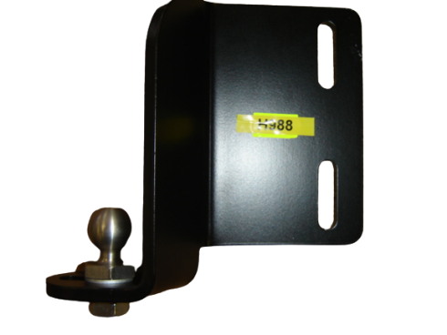 | H988  IG3 DOOR SHAFT SUPPORT  RH ASSY  # PIVOT BOLT = G951 | H988 Ventura WRIGHTBUS ECLIPSE SD IG3 + GEMINI DD IG3, ADL E400 DD IG3, EAST LANCS SD IG3 + OLYMPUS DD IG3, POLISH SCANIA OMNICITY DD IG3  33-11187
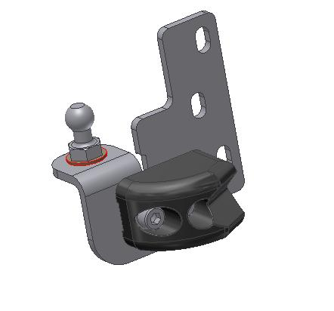 | I269  PS BOTTOM SUPPORT  LH ASSY  # PIVOT BOLT = B688  # CATCH BLOCK = J405 | I269 Ventura OPTARE SD PS VERSA + TEMPO  66900369
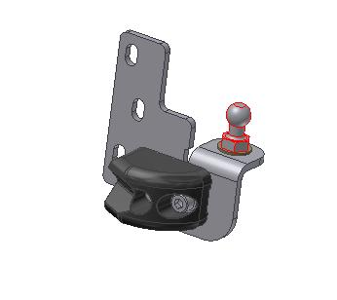 | I270  PS2 BOTTOM SUPPORT  RH ASSY  # PIVOT BOLT = B688  # CATCH BLOCK = J405 | I270 Ventura OPTARE SD PS VERSA + TEMPO  66900370
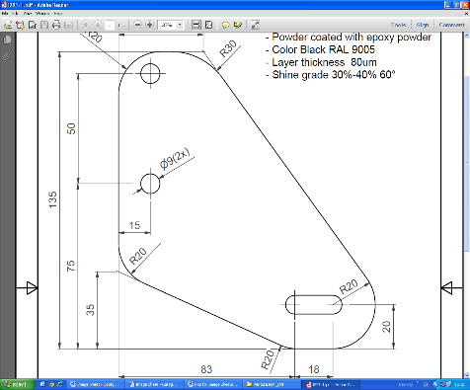 | I291  IG3 DOOR GUIDING BRACKET | I291 Ventura EAST LANCS OLYMPUS DD IG3
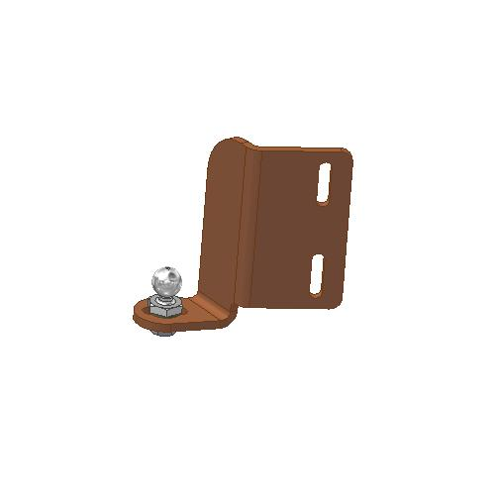 | I357  IG3 DOORSHAFT SUPPORT  LH 100 ASSY  # PIVOT BOLT = G951 | I357 Ventura ADL E200 SD IG4 + E300 SD IG3/IG4 + E400 DD IG3/IG4, TEMSA SD IG4  6600008N33
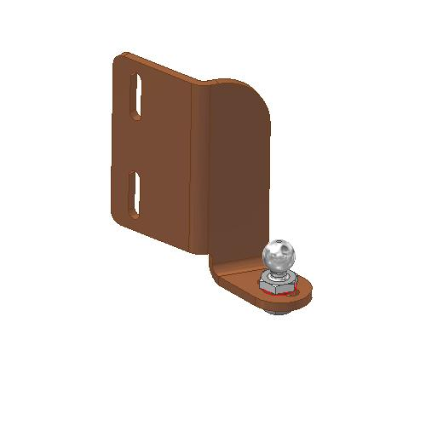 | I358  IG3 DOORSHAFT SUPPORT  RH 100 ASSY  # PIVOT BOLT = G951 | I358 Ventura ADL E200 SD IG4 + E300 SD IG3/IG4 + E400 DD IG3/IG4, TEMSA SD IG4  6600009N33
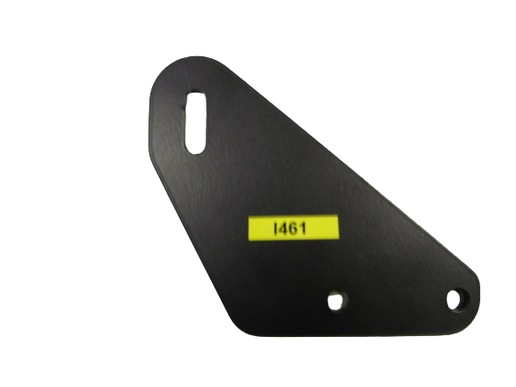 | I461  IG3 GUIDING BRACKET | I461 Ventura ADL E400 DD IG3  6690825N33
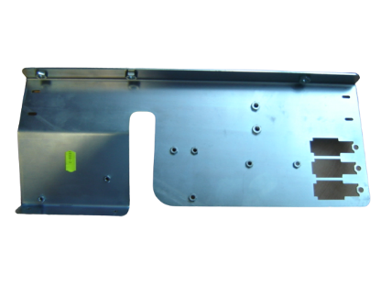 | I500  PS CONTROL MOUNT PLATE  (REV 8 LATEST VERSION) | I500 Ventura  6690832D31
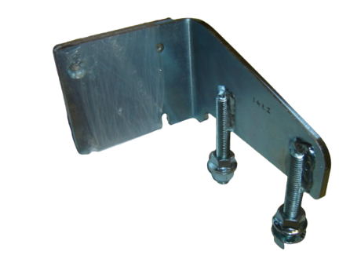 | I741  PS ADAPTER BRACKET LH | I741 Ventura  6690800D99
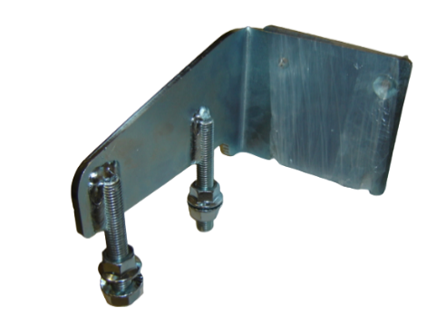 | I801  PS ADAPTER BRACKET RH | I801 Ventura  6690801D99
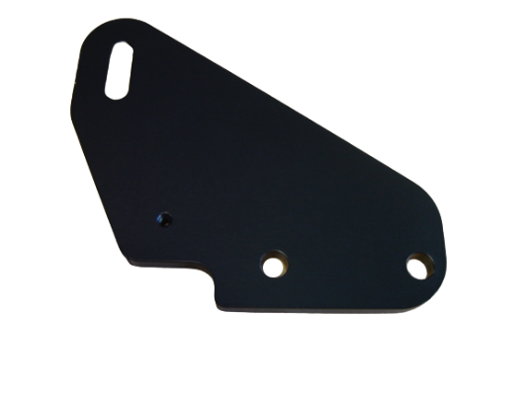 | I944  IG4 GUIDING BRACKET | I944 Ventura  TEMSA SD IG4
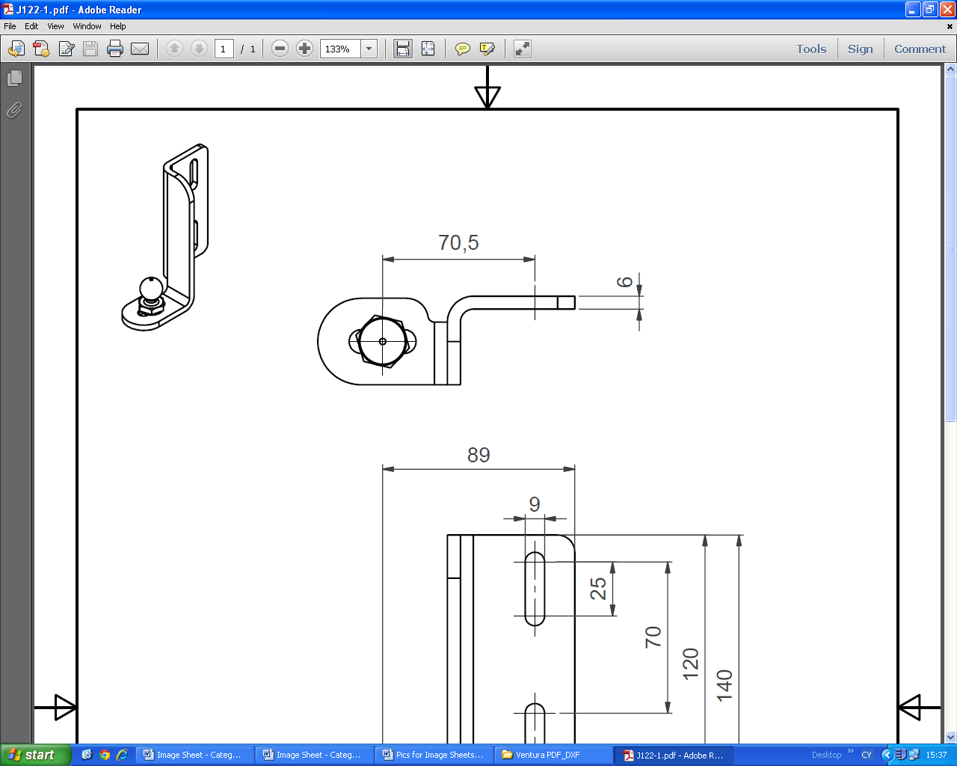 | J122  IG3 DOOR SHAFT SUPPORT  LH ASSY  # PIVOT BOLT = G951 | J122 Ventura MCV IG3
 | J123  IG3 DOOR SHAFT SUPPORT  RH ASSY  # PIVOT BOLT = G951 | J123 Ventura MCV IG3
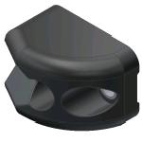 | J405  PS CATCH BLOCK  BOTTOM SUPPORT | J405 Ventura  6690803D252  32455002
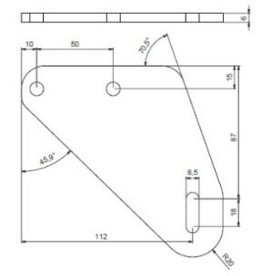 | J964  IG3 GUIDING BRACKET FLAT | J964 Ventura  ADL E200 IG3
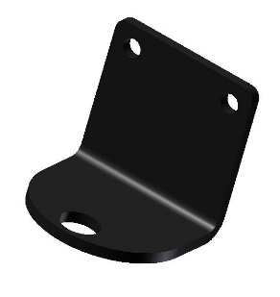 | L778  IG4 LOWER SHAFT (FLAP) BRKT  # BEARING BUSH = L782  # NYLON WASHER = A497 | L778 Ventura  DEV-00172  6690818F75
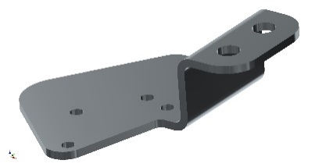 | M049  PS MICROSWITCH BRACKET | M049 Ventura
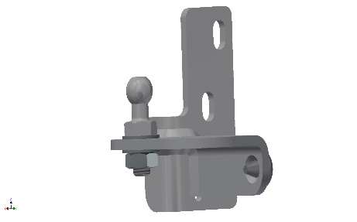 | M106  RS BOTTOM SUPPORT  LH ASSY  # PIVOT BOLT = B688 | M106 Ventura  6690808D237
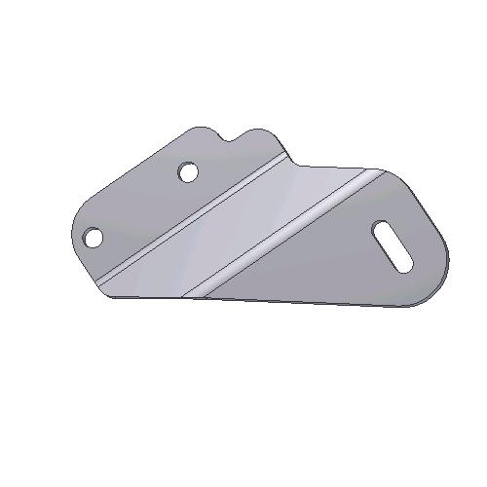 | M592  IG4 GUIDING BRACKET LH | M592 Ventura ADL E200 SD IG4 + E300 SD IG4 + E400 DD IG4  6690811D177
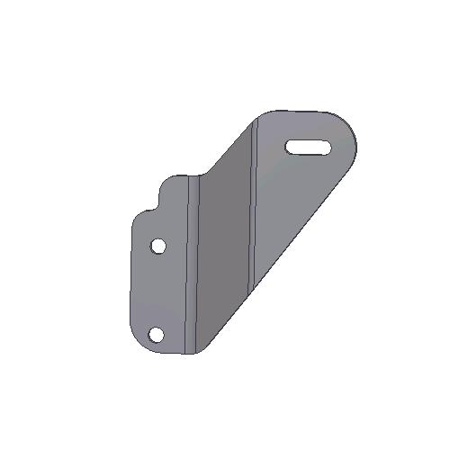 | M593  IG4 GUIDING BRACKET RH | M593 Ventura ADL E200 SD IG4 + E300 SD IG4 + E400 DD IG4  6690812D177
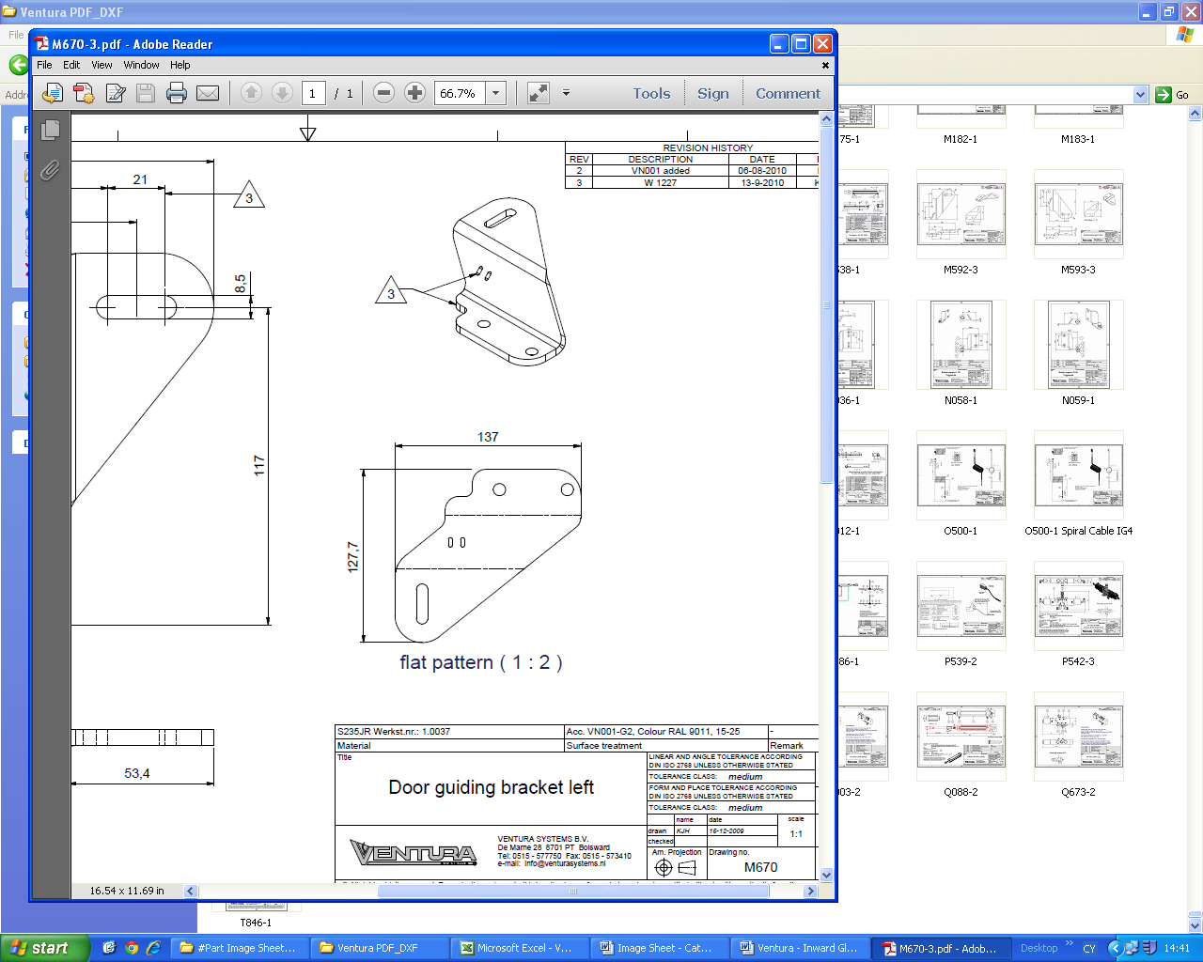 | M670  IG4 GUIDING BRACKET LH | M670 Ventura MCV SD 112/124RLE IG4
 | M671  IG4 GUIDING BRACKET RH | M671 Ventura MCV SD 112/124RLE IG4
 | M717  IG4 GUIDING BRACKET | M717 Ventura WRIGHTBUS ECLIPSE SD IG4 + GEMINI DD IG4 + NBFL DD IG4/IG4 PLAT  DEV-00107
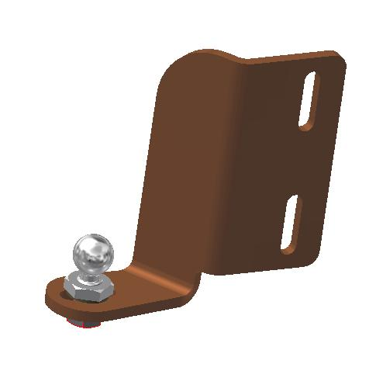 | N035  IG4 DOOR SHAFT SUPPORT  LH ASSY  # PIVOT BOLT = G951 | N035 Ventura MCV SD 112/124RLE IG4  66000003
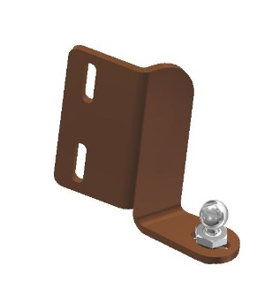 | N036  IG4 DOOR SHAFT SUPPORT  RH ASSY  # PIVOT BOLT = G951 | N036 Ventura MCV SD 112/124RLE IG4  66000004
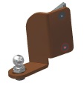 | N058  IG4 BOTTOM SUPPORT  LH ASSY 90  # PIVOT BOLT = G951 | N058 Ventura  WRIGHTBUS ECLIPSE SD IG4 + GEMINI DD IG4 + STREETLITE SD IG4 + NBFL DD IG4  DEV-00067  DEV-00944  DP733703
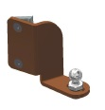 | N059  IG4 BOTTOM SUPPORT  RH ASSY 90  # PIVOT BOLT = G951 | N059 Ventura  WRIGHTBUS ECLIPSE SD IG4 + GEMINI DD IG4 + STREETLITE SD IG4 + NBFL DD IG4  DEV-00068  DEV-00945  DP038200
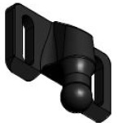 | N427  IG4/PS2 PIVOT POINT | N427 Ventura  WRIGHTBUS PS2, MCV DD EVOSETI PS2  DEV-00412  6690862L002
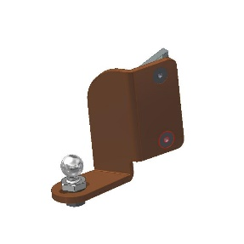 | N881  IG4 BOTTOM SUPPORT  LH ASSY 90  # PIVOT BOLT = G951 | N881 Ventura  ADL E200/E400 IG4 +  MCV EVOSETI DD IG4  6690804N196
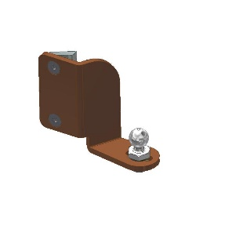 | N882  IG4 BOTTOM SUPPORT  RH ASSY 90  # PIVOT BOLT = G951 | N882 Ventura  ADL E200/E400 IG4 +  MCV EVOSETI DD IG4  6690805N196
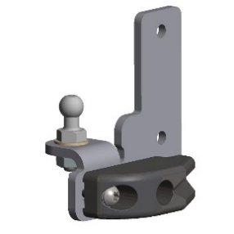 | O272  PS2 BOTTOM SUPPORT  LH ASSY  # PIVOT BOLT = B688  # CATCH BLOCK = P261 | O272 Ventura WRIGHTBUS NBFL DD PS  DEV-00104
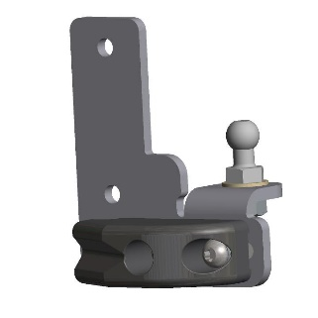 | O273  PS2 BOTTOM SUPPORT  RH ASSY  # PIVOT BOLT = B688  # CATCH BLOCK = P261 | O273 Ventura WRIGHTBUS NBFL DD PS  DEV-00106
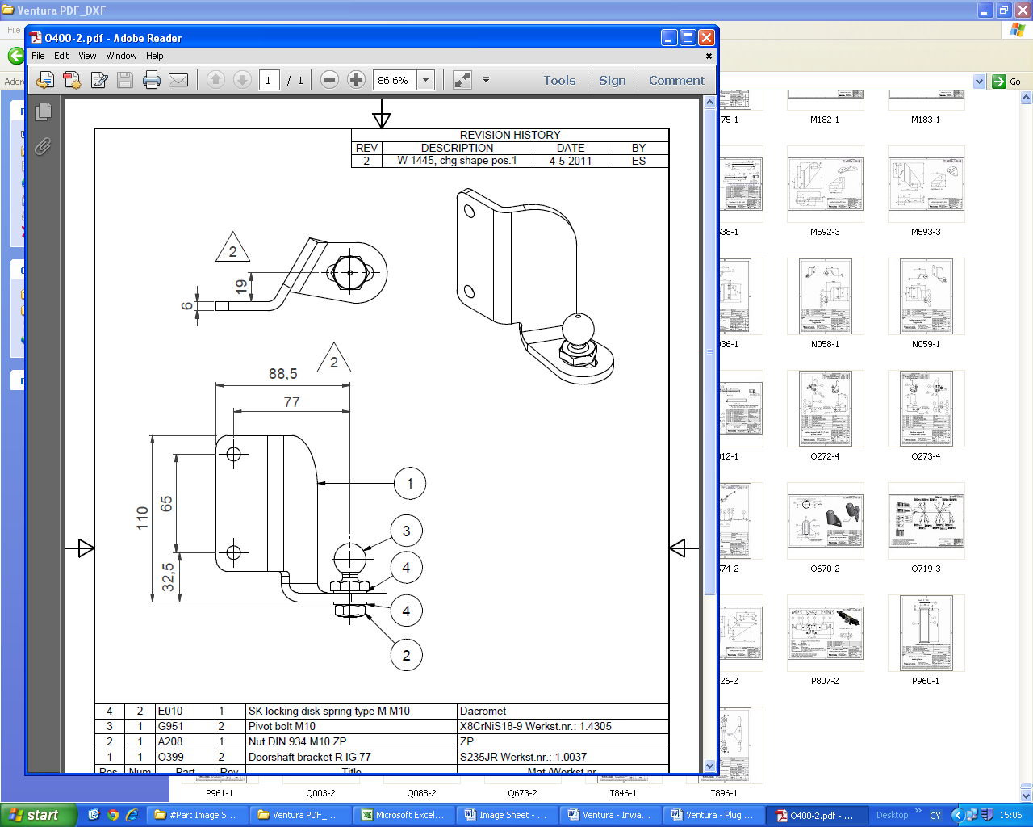 | O400  IG4 BOTTOM SUPPORT  RH ASSY 77 (TOGGLE NUT)  # PIVOT BOLT = G951 | O400 Ventura WRIGHTBUS NBFL DD IG4/IG4 PLAT  DEV-00096
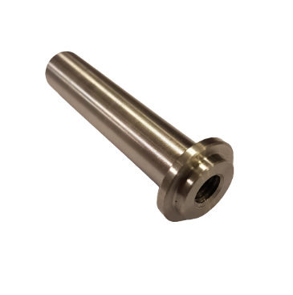 | O412  IG4 PIVOT POINT BOTTOM | O412 Ventura  WRIGHTBUS NBFL  DEV-00318
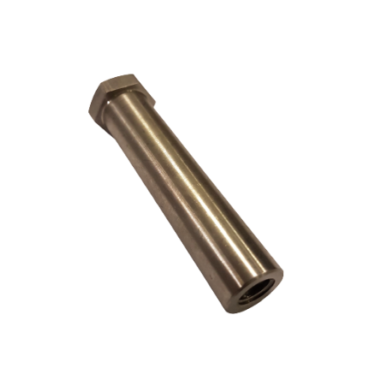 | O413  IG4 PIVOT POINT TOP | O413 Ventura  WRIGHTBUS NBFL  DEV-00317  DEV-00193
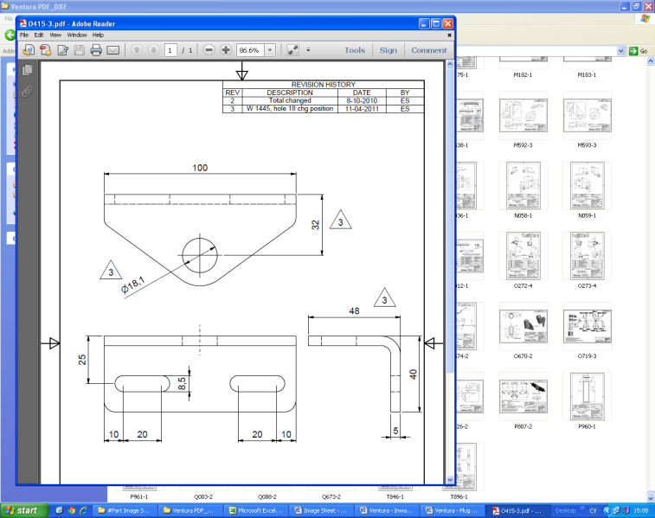 | O415  IG4 CURVED DOOR  TOP SUPPORT | O415 Ventura WRIGHTBUS NBFL DD IG4 PLAT  DEV-00155
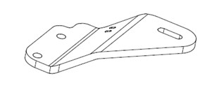 | O553  IG4 GUIDING BRACKET LH | O553 Ventura  6690849S01
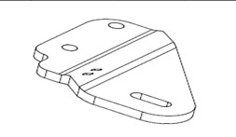 | O554  IG4 GUIDING BRACKET RH | O554 Ventura  6690849S01
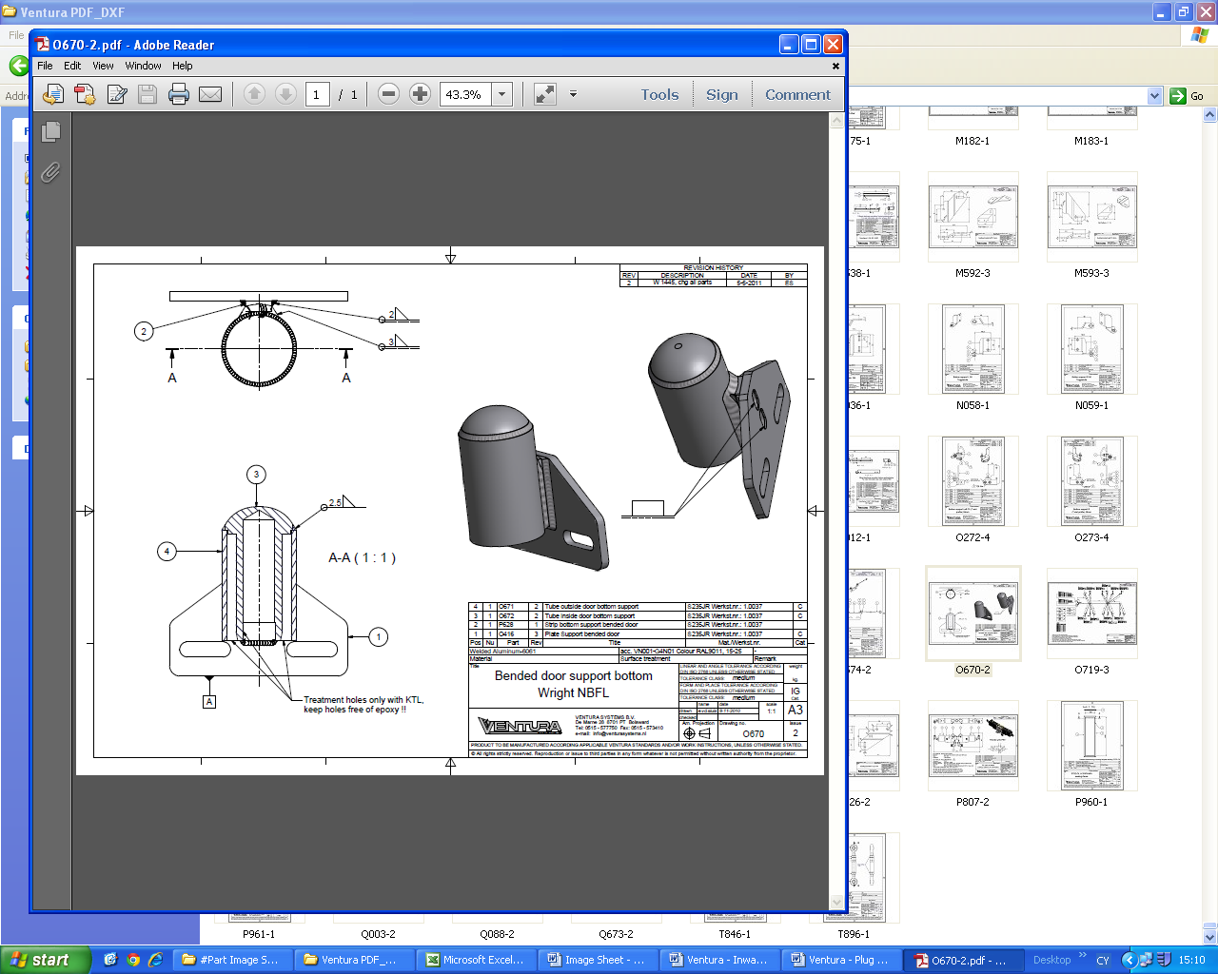 | O670  IG4 CURVED DOOR  BOTTOM SUPPORT | O670 Ventura WRIGHTBUS NBFL DD IG4 PLAT  DEV-00156
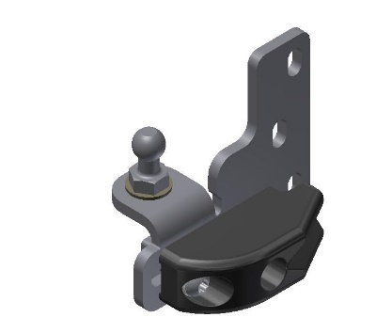 | P256  PS2 BOTTOM SUPPORT  LH ASSY  # PIVOT BOLT = B688  # CATCH BLOCK = P261 | P256 Ventura  MCV DD EVOSETI PS2  6616802P375  66903829
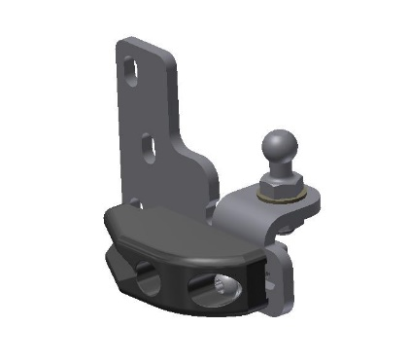 | P257  PS2 BOTTOM SUPPORT  RH ASSY  # PIVOT BOLT = B688  # CATCH BLOCK = P261 | P257 Ventura  MCV DD EVOSETI PS2  6616803D375  66903830
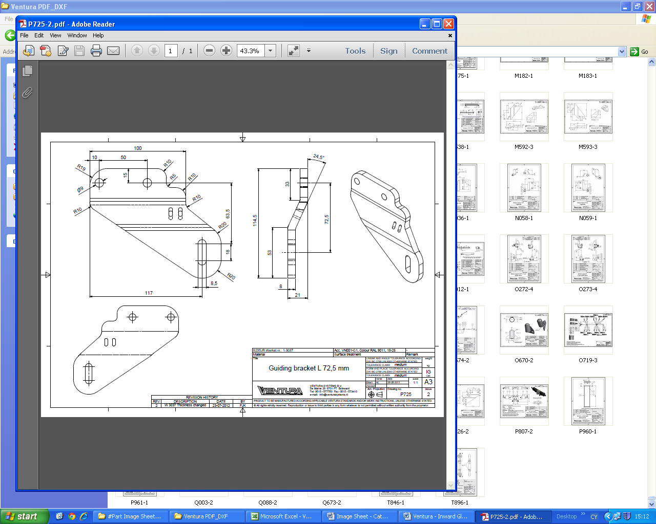 | P725  IG4 GUIDING BRACKET LH  72.5mm | P725 Ventura WRIGHTBUS ECLIPSE SD IG4
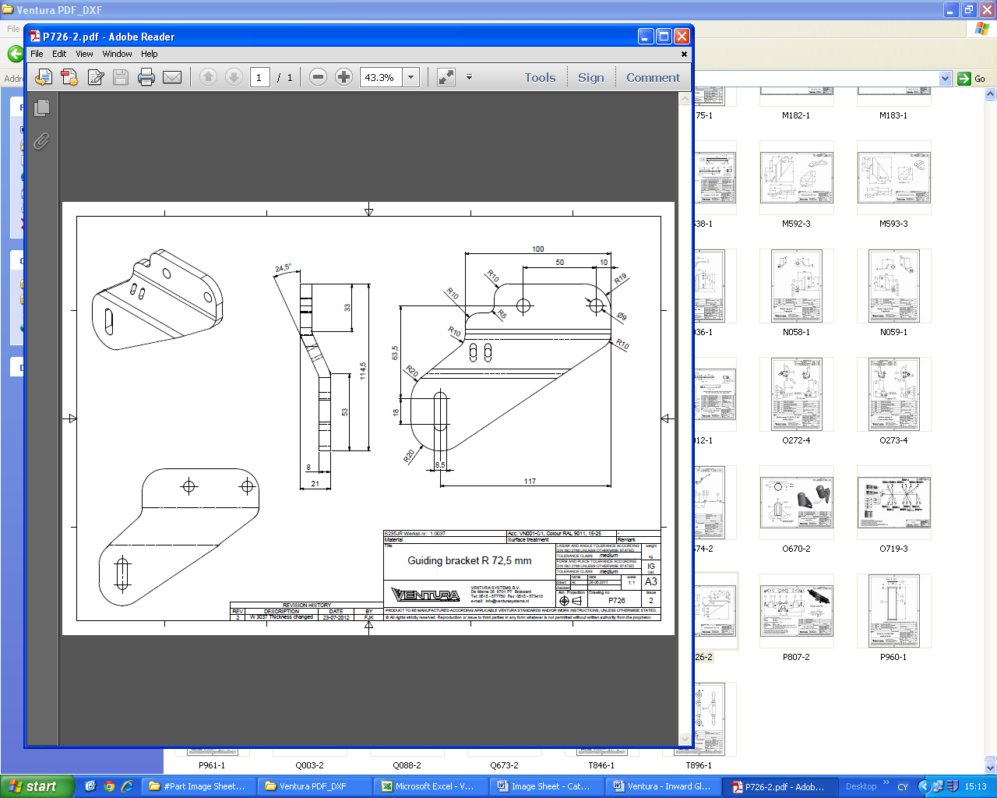 | P726  IG4 GUIDING BRACKET RH  72.5mm | P726 Ventura WRIGHTBUS ECLIPSE SD IG4
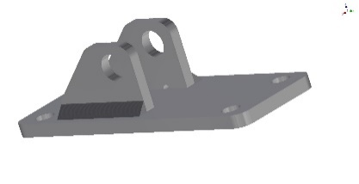 | Q348  RS DRIVE BRACKET (R643) | Q348 Ventura
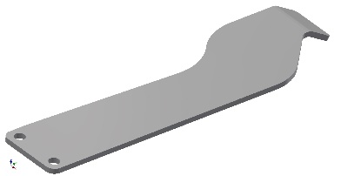 | S752  RS CYLINDER DRIVE BRACKET  SWITCH PLATE (R643) | S752 Ventura
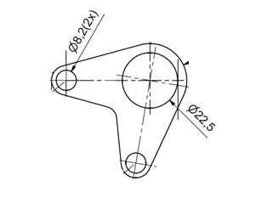 | S930  PS2 CYLINDER BRACKET | S930 Ventura
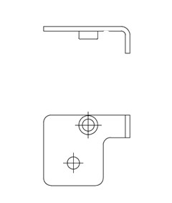 | S950  PS CABLE BRACKET | S950 Ventura
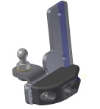 | T986  PS2 BOTTOM SUPPORT  LH ASSY  # PIVOT BOLT = B688  # CATCH BLOCK = P261 | T986 Ventura  WRIGHTBUS PS2  DEV-00416  DP737061
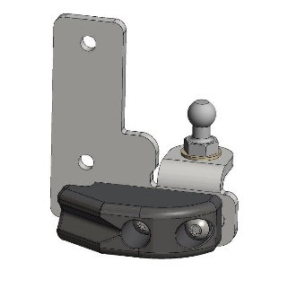 | T987  PS2 BOTTOM SUPPORT  RH ASSY  # PIVOT BOLT = B688  # CATCH BLOCK = P261 | T987 Ventura  WRIGHTBUS PS2  DEV-00481  DP737066
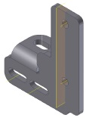 | T988  BOTTOM SUPPORT LH | T988 Ventura  DEV-00417
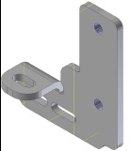 | T989  BOTTOM SUPPORT R H | T989 Ventura  DEV-00420
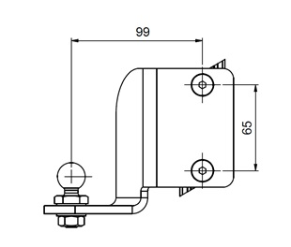 | U537  IG4 BOTTOM SUPPORT  LH ASSY  # PIVOT BOLT = G951 | U537 Ventura  6690806S01
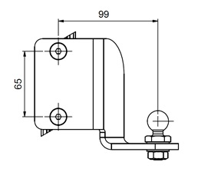 | U538  IG4 BOTTOM SUPPORT  RH ASSY  # PIVOT BOLT = G951 | U538 Ventura  6690805S01
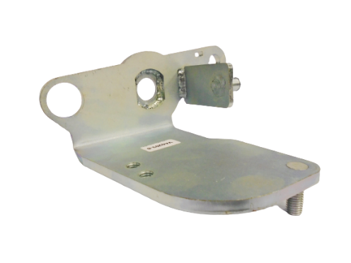 | VA0203  PS LH END PIECE | VA0203 Ventura
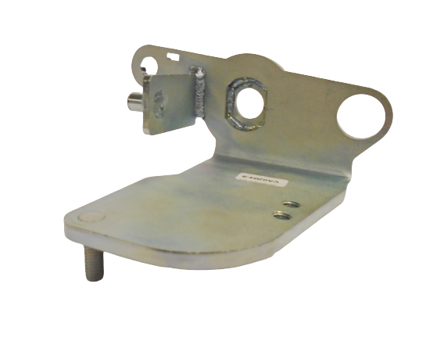 | VA0204  PS RH END PIECE | VA0204 Ventura
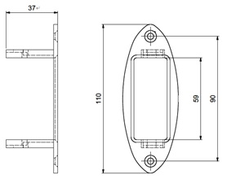 | VA0541  IG4 SENSOR BRACKET | VA0541 Ventura  6690822L120
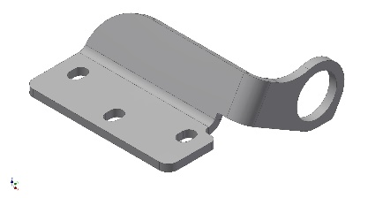 | VA0721  CYLINDER BRACKET | VA0721 Ventura
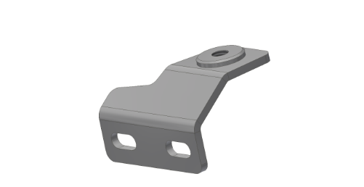 | VA0912  PS ROLLER BRACKET  # USED WITH ROLLER E529  # ROLLER BOLT = VA0557 | VA0912 Ventura  6690864L002
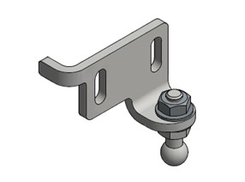 | VA2123  PS2 DOORSHAFT ADJUST BRACKET  LH ASSY  # PIVOT BOLT = B688 | VA2123 Ventura
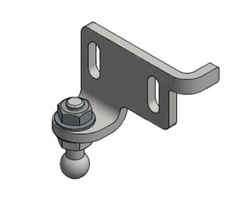 | VA2124  PS2 DOORSHAFT ADJUST BRACKET  RH ASSY  # PIVOT BOLT = B688 | VA2124 Ventura
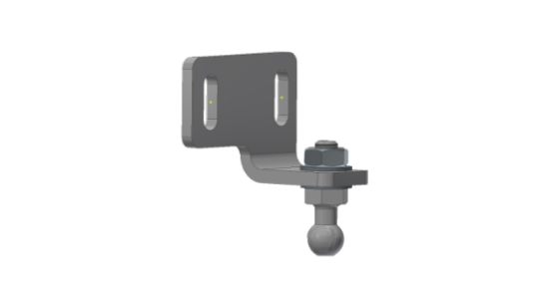 | VA3191  PS2 DOORSHAFT BRKT  LH ASSY 28MM  # PIVOT BOLT = B688 | VA3191 Ventura
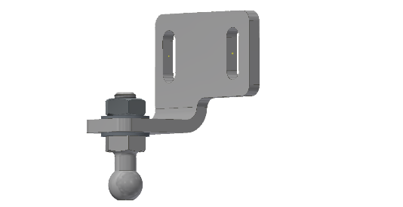 | VA3192  PS2 DOORSHAFT BRKT  RH ASSY 28MM  # PIVOT BOLT = B688 | VA3192 Ventura
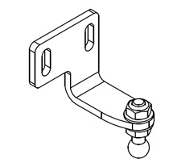 | VA3289  DOORSHAFT ADJUST BRACKET  LH ASSY  # PIVOT BOLT = B688 | VA3289 Ventura
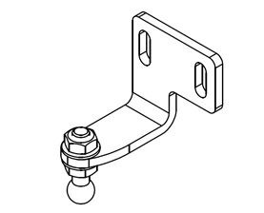 | VA3290  DOORSHAFT ADJUST BRACKET  RH ASSY  # PIVOT BOLT = B688 | VA3290 Ventura
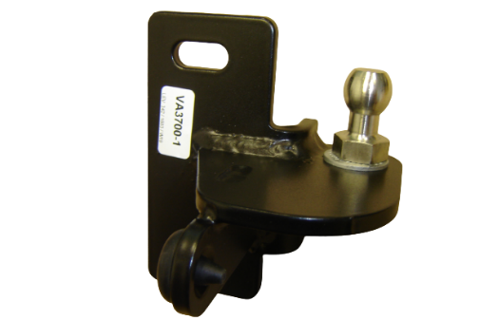 | VA3700  RS BOTTOM SUPPORT  RH ASSY (T-SLOT)  # PIVOT BOLT = B688 | VA3700 Ventura  WRIGHTBUS NBFL PLAT RS  DEV-00601
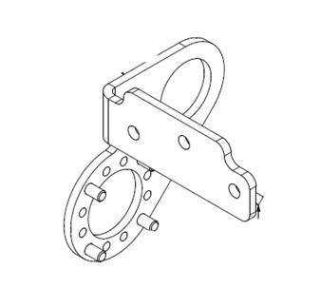 | VA3874  PSE Motor Bracket | VA3874 Ventura
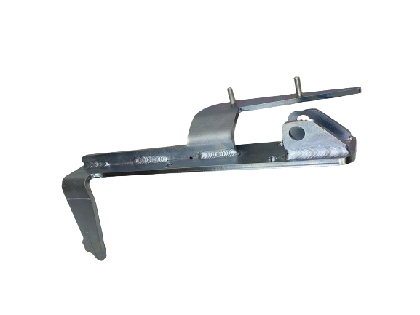 | VA5480  RS DRIVE BRACKET L | VA5480 Ventura
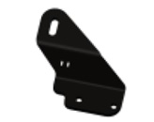 | VA6793  IG4 GUIDING BRACKET LH | VA6793 Ventura
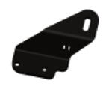 | VA6794  IG4 GUIDING BRACKET RH | VA6794 Ventura
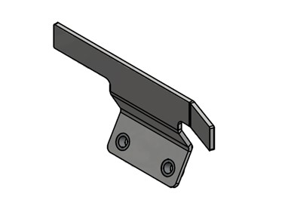 | VA8532  PS2 SWITCH CAM BRAKCET | VA8532 Ventura  6690846S01
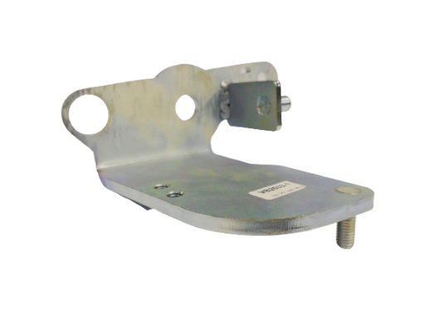 | VB2533  PS LH END PIECE | VB2533 Ventura
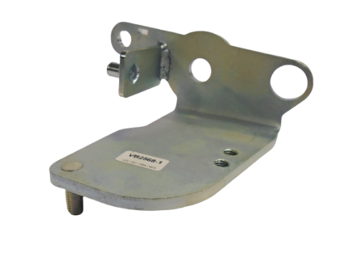 | VB2568  PS RH END PIECE | VB2568 Ventura

.

